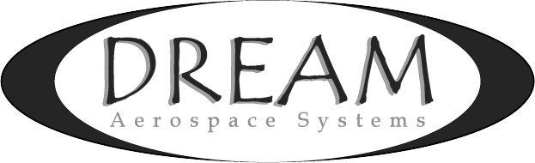
20 Years of Improvements
Using LRO Lunar Images to Quantify Earth-based Instrument
Shane Santi – Founder & President
v4, June 4th, 2017 - Copyright Dream Aerospace Systems
keywords: DIQ, lightweight mirrors, lightweight telescopes, carbon fiber telescopes, precision optics, precision optical instruments

I grew up in Iowa (center of the US) and have used telescopes since I was 10 years old (1980). I was told over & over again that the limiting factor for ground-based telescope performance was the atmosphere. For decades I believed it. Because the atmosphere can’t defend itself, its super-villain status has persisted. But is it true?

In astronomy we hear about far away, high elevation mountaintops with “pristine” conditions for telescopes;
- Dark skies (little to no light pollution),
- 300+ clear nights per year,
- Low humidity (eliminates the typical and substantial issues caused by dew) and,
- It’s above the densest part of our atmosphere, producing site seeing that is below 1 arc-second.

Telescopes placed at such sites typically do have higher relative installed performance than those near sea level. However, the first three factors above can and should produce that result. Still, the average and relative “higher” performance at these locations is typically nowhere near that of multi-million dollar, meter to meter plus-class facilities that use actual engineering to partially address age-old performance loss factors. Even without Adaptive Optics (AO) these much larger diameter telescopes are achieving better installed performance.

The performance of smaller Commercial-Of-The-Shelf (COTS) telescopes and enclosures isn’t close to the diffraction-limit, which is 0.461 arc-second for a 300mm aperture at 550nm wavelength. Often telescopes on pristine mountaintops average 1.5 to 2.5 arc-seconds, if not worse. Even if a 300mm aperture achieved 1.5 arc-seconds installed performance, that’s still more than 3x worse than the diffraction-limit. Is performance being left on the floor because the atmosphere was assumed to be the limiting factor? Do we have to be on a pristine mountaintop to achieve sub arc-second installed performance? These are questions I started asking myself over a quarter century ago.

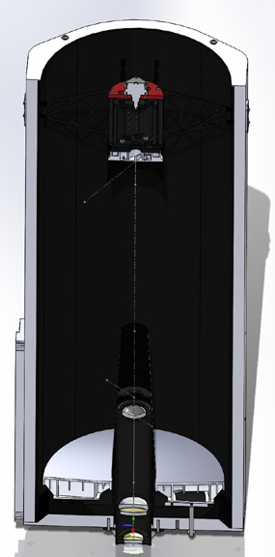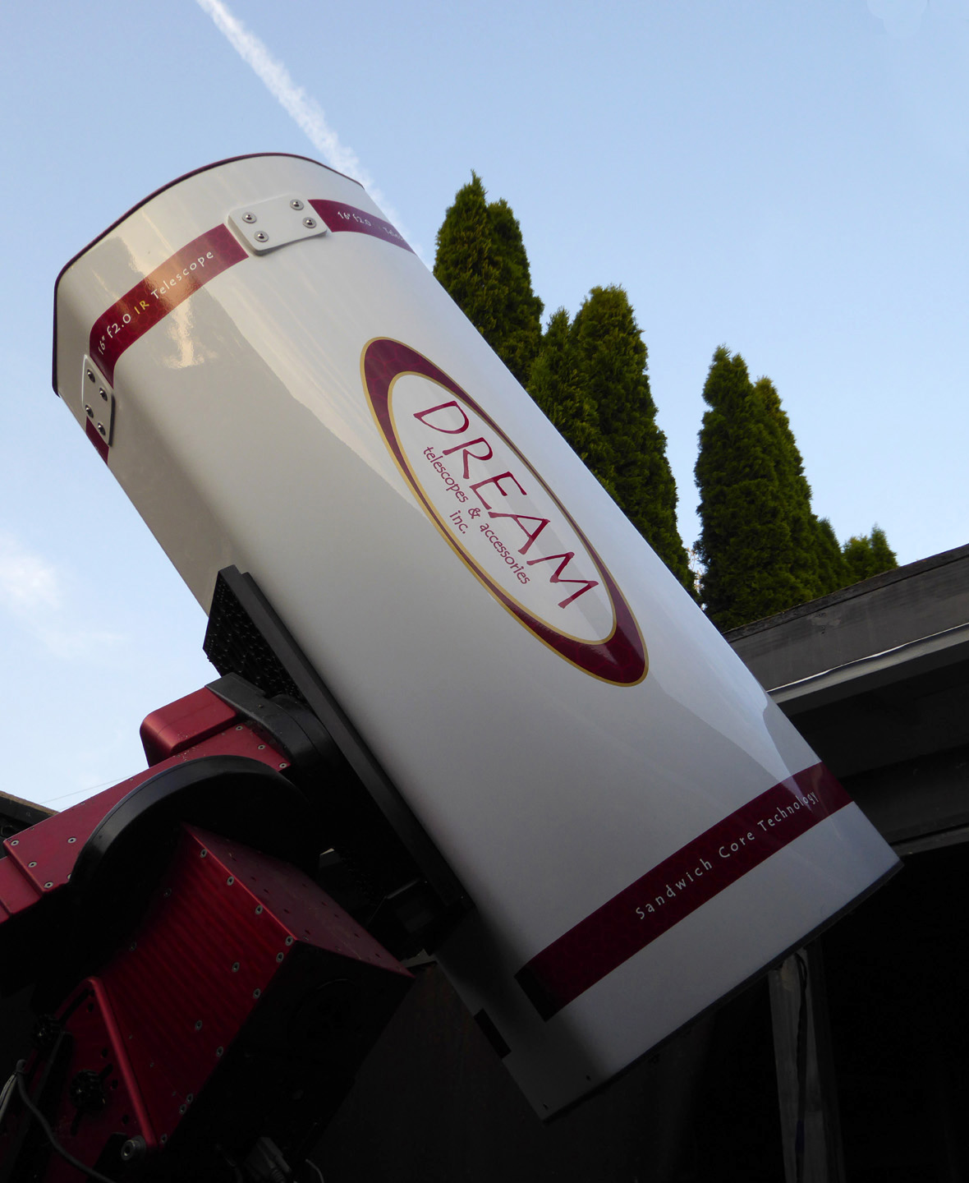
Fig. 1: Dream 400mm instrument - SolidWorks CAD model (left) & actual telescope during testing in Nazareth, PA.

Dream Aerospace Systems created a custom 400mm Clear Aperture (CA) lightweight f2 IR telescope (see Fig. 1) for the USAF. The 2-mirror portion of the system was a Classical Cassegrain with a system focal ratio of f6.5. NASA's Lunar Reconnaissance Orbiter (LRO) images were used to quantify the 2-mirror instrument’s raw, single-frame image resolution from test images taken under the stars prior to shipping it to the customer. The camera’s detector uses 3.75µm pixels, which means the 400mm f6.5 2-mirror system operates at 0.3 arc-second/pixel. The exposures were 1/80th second, while allowing the full visual spectrum onto the detector. The camera’s peak sensitivity is 550nm, which coincides with human vision’s dark-adapted peak sensitivity of 555nm.

LRO images show the Dream instrument achieved 0.82 arc-second raw performance (no stacking or processing) from the center of Nazareth, PA; a 6000-person town in the Northeast at less than 500 feet of elevation. The images were taken while the telescope was surrounded by houses, garages, driveways, sidewalks & streets, all radiating heat at night. The telescope was also looking over a garage during the early evening.

This underscores the value and purpose of this author’s 25+ years dedicated to understanding performance loss factors from optics and optical structures, across three broad realms; optics, mechanics & thermodynamics. That knowledge has been developed into Dream’s cutting edge technologies and ships inside each optical instrument Dream designs and produces. Both the primary mirror (M1) and the secondary mirror (M2) are Dream’s thin-featured, highly-engineered zeroDELTA™ lightweight mirrors; M1 has no features thicker than 3.175mm. These mirrors often equalize hundreds of times faster than solid mirror substrates.

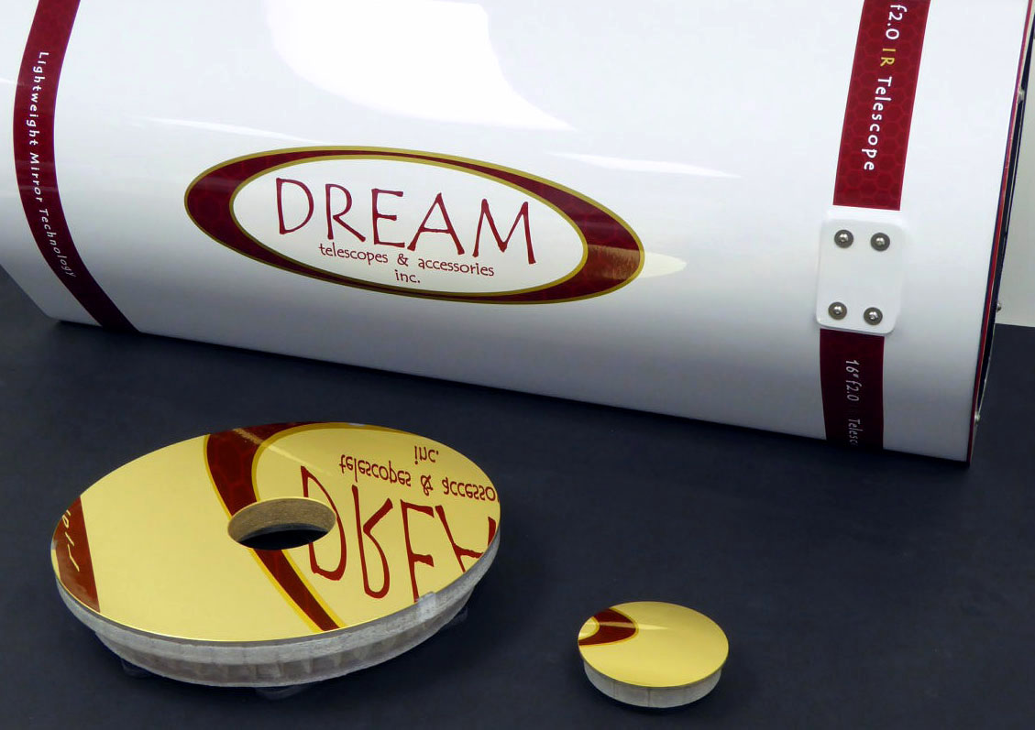
Fig. 2: Dream’s zeroDELTA™ lightweight mirrors and carbon fiber instrument – 0.4m f2 for USAF.

In testing, optimal focus was achieved with only a 0.46mm inward movement of the motorized M2, from the nominal M1 to M2 position. It’s important to keep the spacing of M1 to M2 within tolerance because going outside a given system’s tolerance will initially lead to increased off-axis aberrations (performance loss at the edges of the field), but further despace error will lead to on-axis performance loss as well. If you don’t detect any performance loss outside the nominal spacing range, it’s a clear sign the telescope is not operating at a high level.

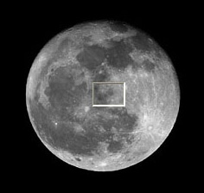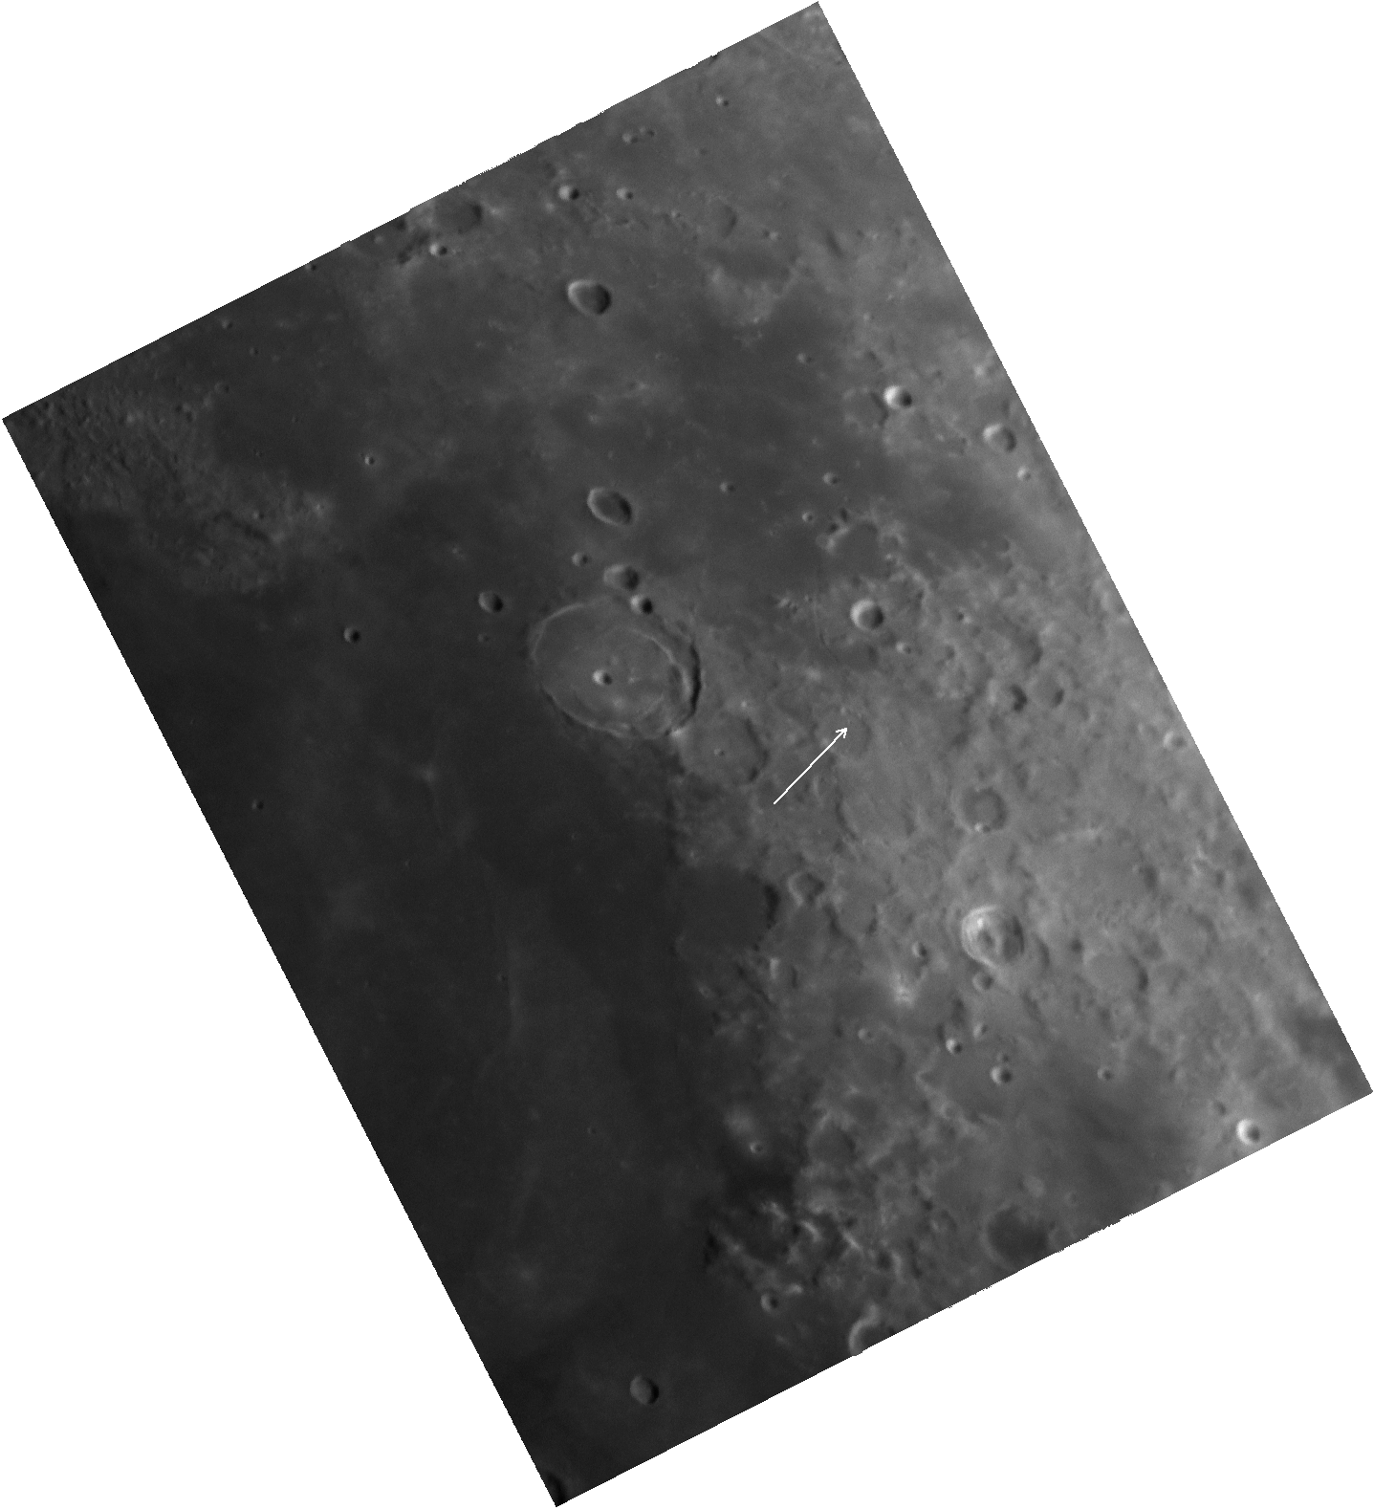
Fig. 3: Simulated field on Moon (left) and raw, single-frame test image from the Dream instrument (right).

The left image below in Fig. 4 was taken by NASA’s LRO, which has mapped the Moon and was taken off the LRO public web site: http://target.lroc.asu.edu/q3/.
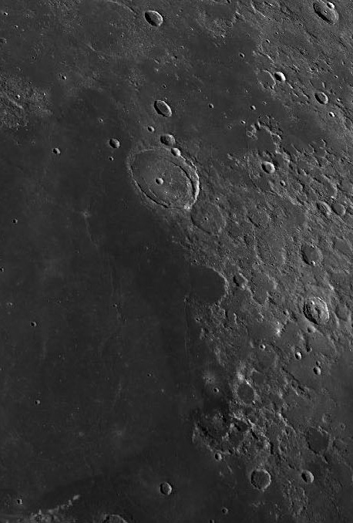
Fig. 4: LRO image of FOV (left) and raw test image from Dream 400mm instrument (right).

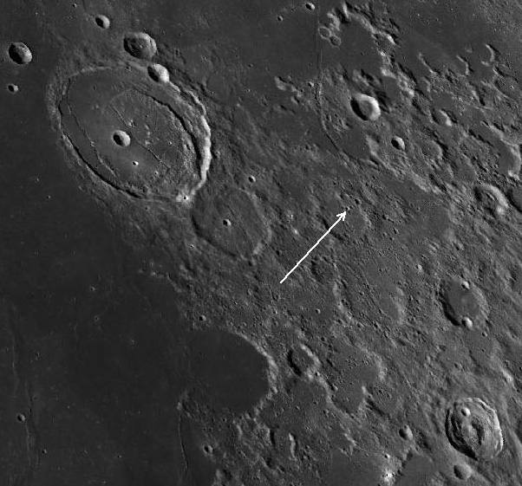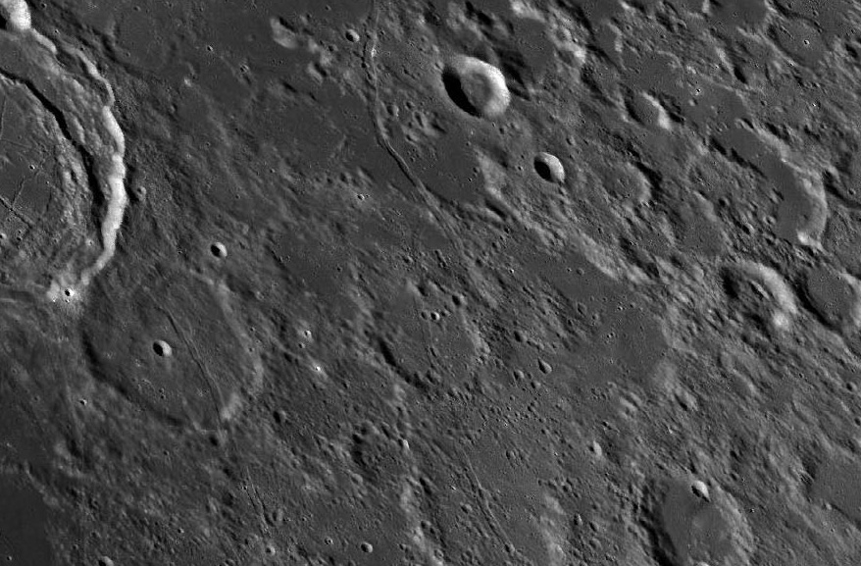
Fig. 5: Closer and closer LRO views of the target area for determining actual resolution.

Fig. 5 shows closer LRO views of the target crater used to determine resolution of the instrument. The left image in Fig. 6 below is an LRO view with a lunar scale; 5km on top and 2mi on the bottom of the scale. The right image in Fig. 6 is a single-frame, raw (unprocessed) test image taken with the Dream 400mm f6.5 instrument.

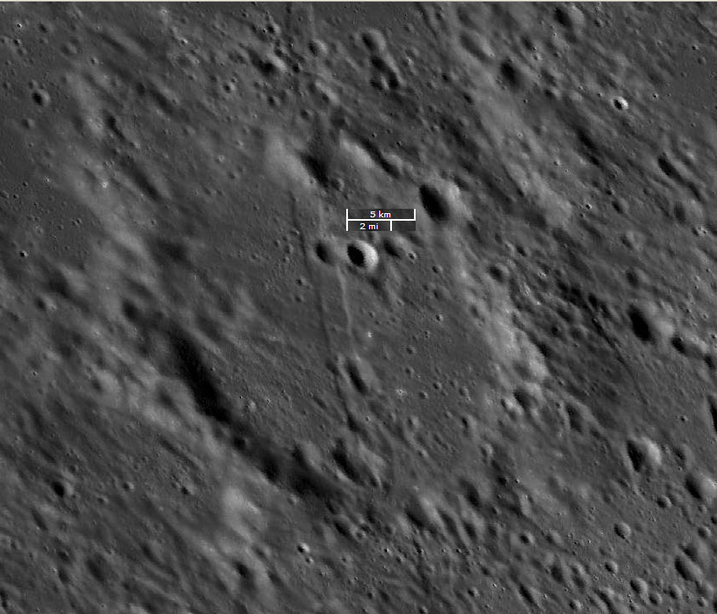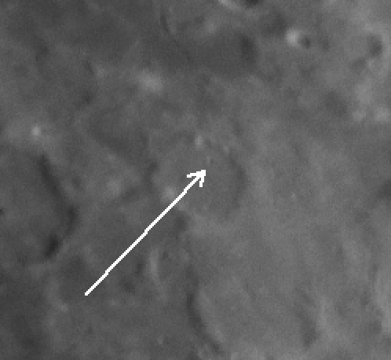
Fig. 6: LRO image (left) and a single-frame, raw test image (right) from the Dream instrument: shown in different scales.

Fig. 7 shows the closest view possible with LRO images. This shows the crater used to help quantify the resolution of the instrument is roughly 2km in diameter. But the single-frame, raw test image (Fig. 6 right) shows both light and dark within this diameter/crater. Conservatively the single-frame, raw test image has achieved lunar surface resolution of roughly 1.5km.

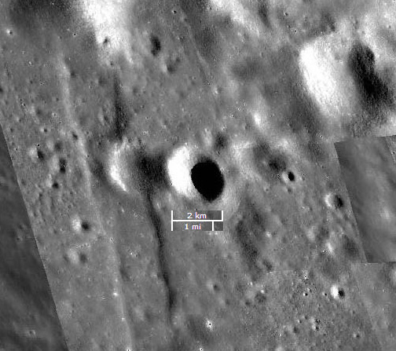
Fig. 7: LRO image with lunar scale showing target crater’s diameter.

The lunar surface resolution can be converted into arc-second resolution from Earth. 0.3 arc-sec/pixel for the camera equates to 0.51-0.59km on the Moon, depending on the distance from Earth to Moon. 1.5km of lunar surface resolution compared to the pixel scale of 0.55km/pixel is 2.727 times greater; 1.5km / 0.55km = 2.727. To determine the resolution of the instrument we take the 2.727 ratio times 0.3 arc-sec/pixel image scale, which equals 0.818 arc-second. The conservatively estimated resolution achieved by the instrument, in a single, unprocessed frame is roughly 0.818 arc-second.

To see a video of 254 consecutive 0.012 second single-frame, raw images highlighting the movement and distortions that atmosphere and the tracking mount caused, click here. The 254 separate, raw images can be found here. The seeing in the video is atmospheric, not mirror-seeing.

Processed Images From The 400mm f6.5 Dream –
LRO images used in Fig. 5 and Fig. 6 have been copied below and arranged to provide a comparison to a processed image stack from the 400mm Dream. Fig. 9, 11 & 14 show the result of stacking & processing 150 of the 254 raw images taken through the 400mm Dream. We thank Jean-Pierre Chiappini for the processing of the test images.
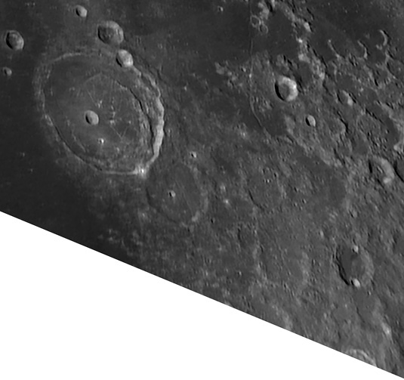
Fig. 8: LRO image. Fig. 9: Processed from 400mm Dream.

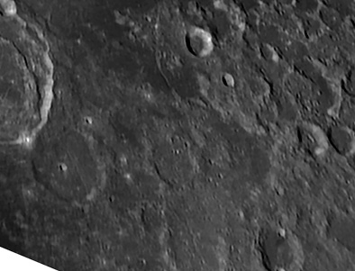
Fig. 10: LRO image. Fig. 11: Processed from 400mm Dream.

Fig. 12: LRO image. Fig. 13: Single-frame raw image –400mm Dream.

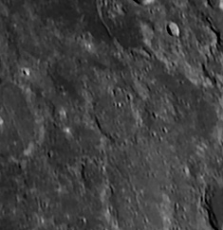
Click here to see a full frame image of the stacked & processed image.
Fig. 14: Processed from 400mm Dream.

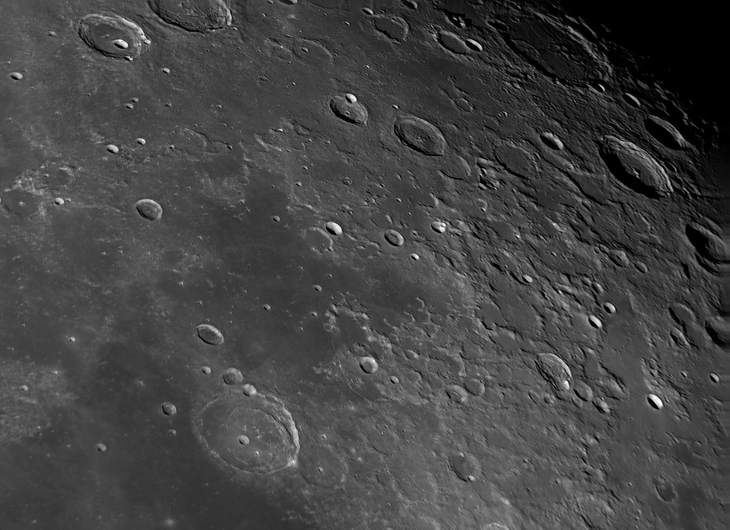
Fig. 15: Processed from 400mm f6.5 Dream. Using a very small number of total raw frames.

Achieving Higher, World-Leading Installed Performance; Higher Signal, Less Noise –
The spacing of M1 to M2 was mentioned earlier because it is one of a great many factors that influence the final performance of an optical system. Test documents of individual optical surfaces don’t tell the whole story.

Another aspect to final performance is related to the radius of each mirror. The radius tolerance for each mirror of this 400mm f2 IR telescope was +/-0.1%. Using this tolerance M1’s radius could be 2413.0mm, +/-2.4mm, while M2’s radius could be 1143mm, +/-1.1mm. M1’s finished radius was only 0.218mm (0.009%) long; 2413.218mm. M2’s finished radius was only 0.008mm (0.0007%) long; 1143.008mm. M2 was also finished with a 2Å (0.2nm) RMS surface roughness, which is a full magnitude smoother than visual spectrum standards require.

Going outside a given system’s tolerance, for M1 to M2 spacing, radius tolerance for each optic, Wave Front Error (WFE), optical alignment, back focus, focus, etc., will all increase aberrations. It’s critical for an optical instrument designer to evaluate and try to control these, as well as many other factors. Remember, there are very, very few errors that make a system better. Most can only do one thing; degrade performance.

Without moving the instrument to a pristine mountaintop two simple alternatives can potentially provide even higher resolution in the single-frame, raw images:
- The use of a UV filter – shorter wavelengths provide higher resolution.
- Switching to a camera with smaller pixels.

Taking thousands of images and stacking only the best 3-5% of those will greatly improve the processed image(s) as well. This was not done because the goal was to show the raw performance of the Dream instrument. The performance within each Dream optical instrument is the result of over 25 years of studies, knowledge, experiences & experiments, while also developing technologies at Dream that virtually eliminate mirror & telescope seeing, tube flexure, mirror distortions (due to both bending and temperature), optical finishing & testing and so much more. Dream's installed performance leaves the object in the signal, instead of burying it in the noise.

Processing is a subjective procedure that is never 100% clean. It can also show unrealistic performance, especially when doing the kind of Lucky Imaging described in the above paragraph. Lucky Imaging does NOT show the raw performance of the optical system. This is another myth, based on a lack of knowledge of Lucky Imaging. Processing images strips away the ability to make an apples to apples comparison between two instruments. Systems that offer better raw images will always outperform those that need processing to “achieve quality.”

High Performance Doesn't Fear Change. It Defies The Status Quo.™
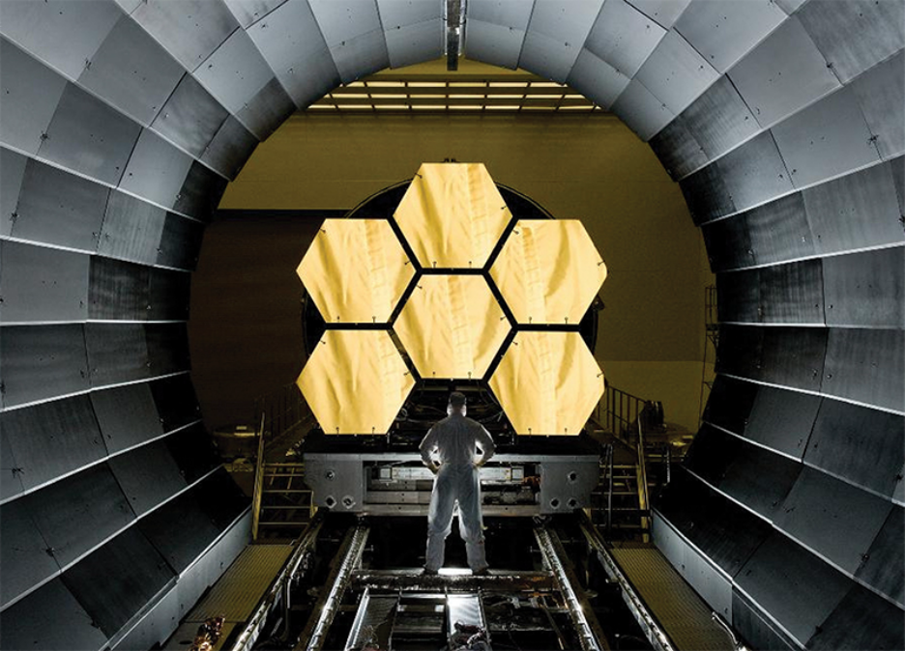
Dream developed its thin-featured zeroDELTA™ highly-engineered lightweight mirrors so they could lead the industry with their lightning-fast thermal equalization, following ever-changing ambient temperature far closer than others in the market, even technologies 300-800% more expensive. The zeroDELTA™ mirrors also lead the industry with the smoothest surfaces with no trace of print through. The mirrors are tested and finished inside Dream using a $200,000 modern interferometer that was developed through NASA for the James Webb Space Telescope. Dream also tests mirrors in their final athermal carbon fiber mirror mounts, typically in our 5m vertical test tower.

"Your company does phenomenal work. There is a lot of thought and heart that goes into your products. Dream's engineering sets their lightweight mirrors apart from competitors. Your engineering goes beyond the lightweight aspect. You focus on actual performance!"
- Ted Kamprath: 40+ years in professional optics, using everything from $1m & $1.5m test rooms to 144" Continuous Polishers.

Dream uses more CFSC™ in our telescopes than any other company in the world. Dream’s low-mass, high-stiffness & athermal CFSC™ (see next page) is used extensively, for 95% or more of the mass of the supporting structures. Others claim they use carbon fiber “extensively” or that they produce “carbon fiber telescopes,” but these are misleading promotional statements because they almost always use just 5-10% carbon fiber in their supporting structures. That carbon fiber is typically solid laminate, which can’t hold a candle to Dream’s CFSC™ (see below). The bulk of their supporting structures is low-cost, high Coefficient of Thermal Expansion (CTE) and easy to machine aluminum.

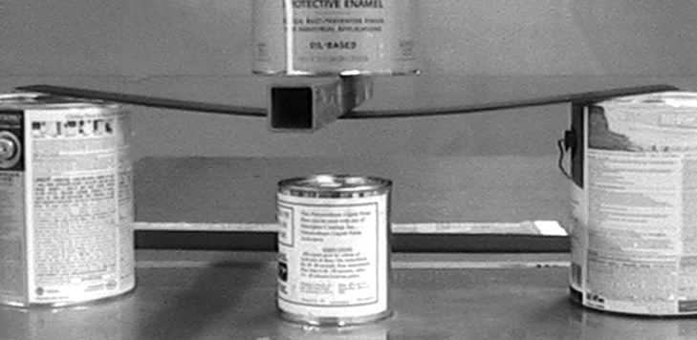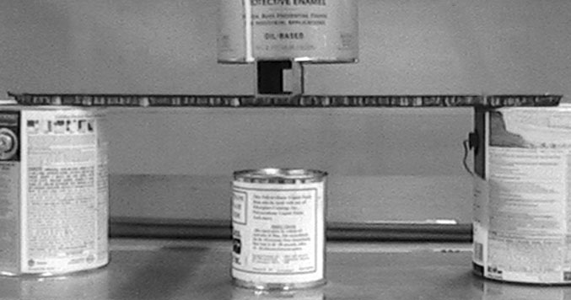
(2003) Internal Dream testing of solid laminate carbon fiber. (2003) Dream’s CFSC™ sandwich core sample - high stiffness.
The above carbon fiber samples show why Dream developed and uses athermal CFSC™ (right image) so extensively, not solid laminate carbon fiber (left image). Solid laminate is far easier and less expensive to design & fabricate, but like anything that is quick & easy, it comes with drawbacks.

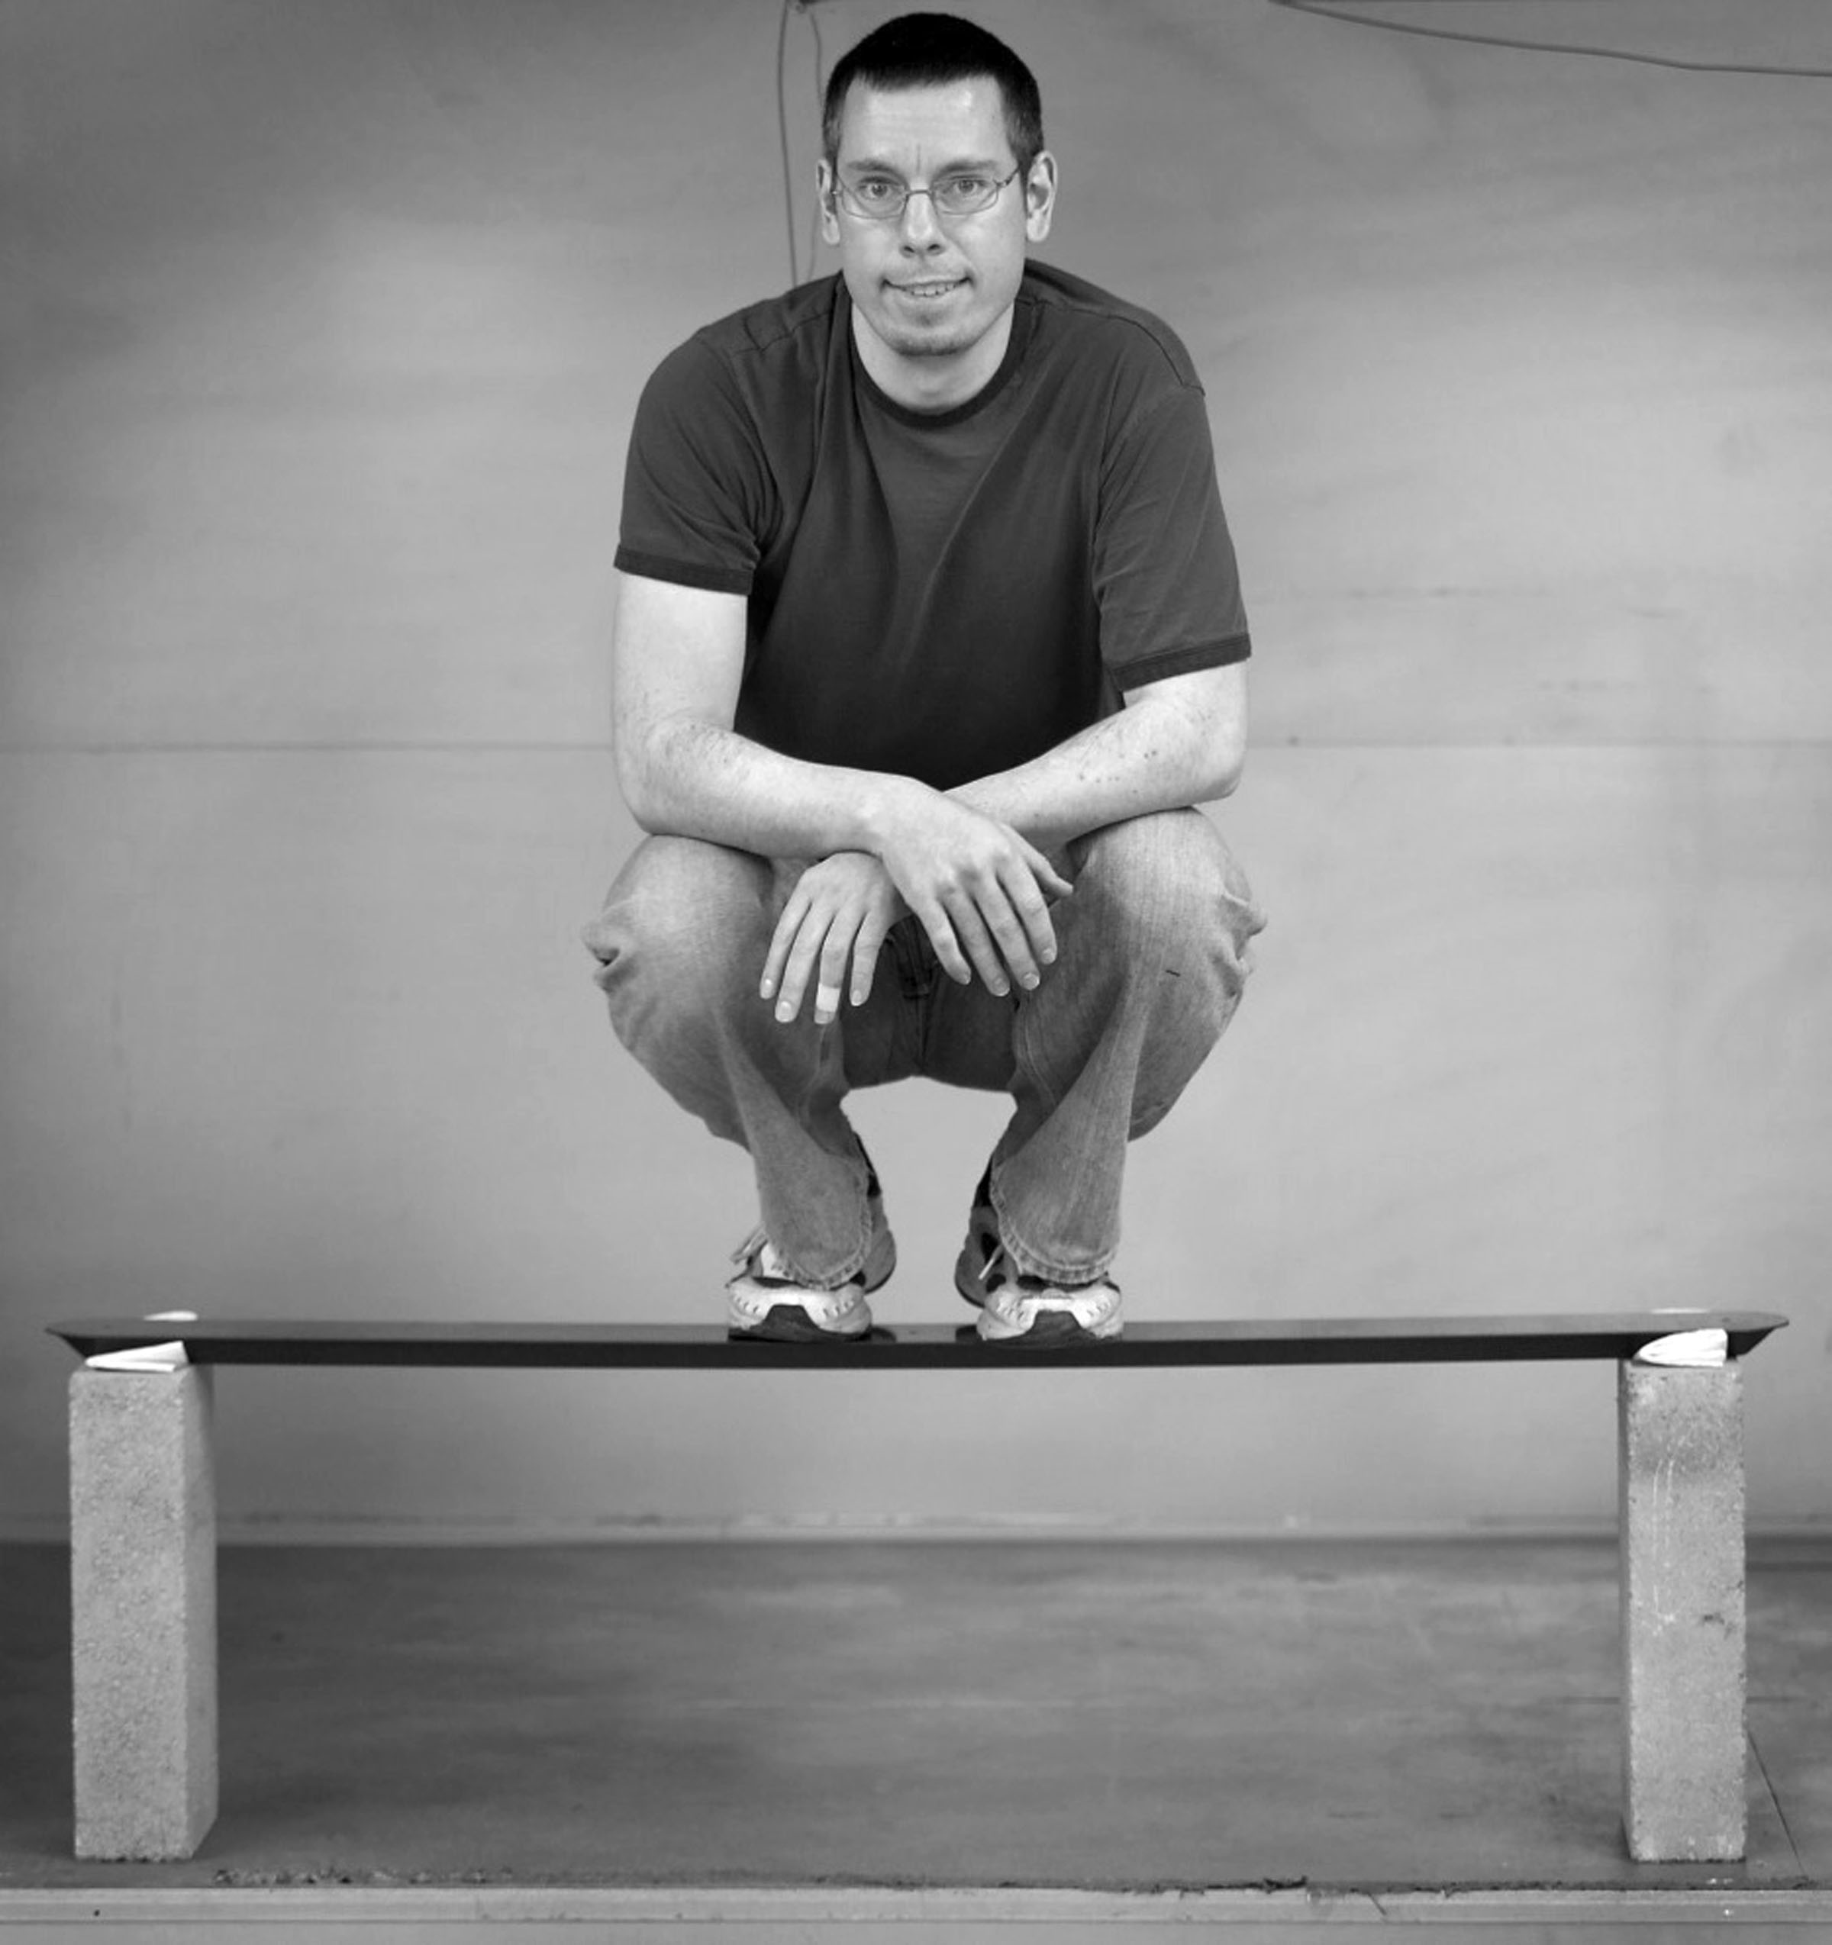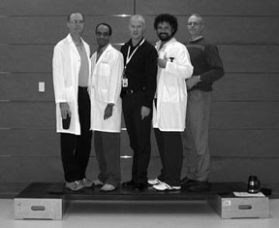
1.85 pound CFSC™ strut with ~195 lb live load. 16.0 pound CFSC™ bio-medical board (6’x2’x1.1”). ~1000 lb live load.

The purpose of any optical support structure is to help maintain the optical surface(s), optical alignment and real-time focus of the optical system. It needs to do this at incredibly small scales, as temperature and telescope angle change. Dream designs and produces all carbon fiber parts in house, tuning our carbon fiber to match the CTE of our zeroDELTA™ lightweight mirrors. This is another of many reasons why Dream leads the world with our installed performance of cutting edge optical systems at such affordable pricing.

Proper Finite Element Analysis (FEA) and modern interferometry both show how common optical shop lens mounts routinely distort 50mm diameter (Ø) lenses. Only those who truly care about the truth of the optical surface recognize this fact. But engineering alone shows us the truth. As aperture goes up, stiffness of an optic falls by the square. When a 50mm Ø shows trefoil from the three spring-loaded lens tongs, it’s beyond naïve to believe a 0.5m mirror is infinity stiff.

The optics & telescope market has done a superb job of convincing buyers that mirrors and lenses are overly stiff. However, the tobacco industry did an equally good job of convincing buyers that cigarette smoking wasn’t harmful. All of this means that testing large-diameter mirrors in their final mirror mounts and at angles mimicking final use angle(s), is not just a frivolous option but has to be the foundation of a system. This too is another main reason Dream can achieve market-leading installed performance. We are chasing the truth of the optical surfaces.

Flexure of mirror mounts, backplates, truss structures, telescope tubes, etc., is one of the Achilles’ heel of all optical systems. It doesn’t matter how “perfect” a mirror or lens is finished. If the lens or mirror mount flexes and distorts the optical surface it supports, performance is degraded. If the system using components that are known to be low in stiffness doesn’t show this performance loss, chances are high that the system still has large performance loss areas. This is why so few have properly addressed the historic performance loss areas. It will force them to scrutinize an ever-growing list of factors, since truly higher performance will show ever-smaller errors. There is no system with zero errors. This too is another common marketing phrase.

Another form of low-stiffness is jitter. This is often wind buffeting of the secondary mirror assembly on low-stiffness open truss telescopes. An open truss telescope structure is typically used to reduce performance loss at the boundary layer of the front-surface optical mirrors; a thermal mass issue. Companies also use trusses to reduce cost and telescope mass.

The still images below show how erratic the boundary layer can be. We want the wind to be perpendicular to the optical axis of the mirrors so they fully flush the optical surface. But the wind speed, direction and telescope angle all vary. This “solution” is hit or miss, at best, because we can’t control the wind speed or direction.

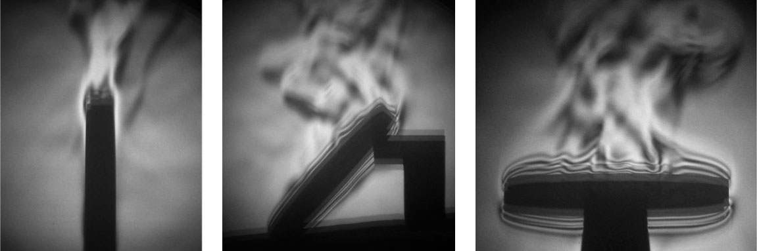
Schlieren images (an imaging technique that detects differences in air density and therefore performance loss)
taken inside Dream of a 220mm Ø solid mirror showing mirror seeing. Boundary layer videos here.

The higher the wind, the more thoroughly it will knock down the boundary layer. However, that increased wind speed on the low-stiffness spider assembly will often induce wind buffeting of the secondary mirror, degrading performance from a different source. This Band-Aid solution to the mirror thermal mass problem has a heavy dose of variability because wind speed and direction, as well as telescope angle, change. In the end it’s difficult to argue that anything was gained by using an open truss.

But this also points out another misconception; that it is the full telescope wind-buffeting that is causing a performance loss via jitter. The truth is that it is mainly the low-stiffness spider/secondary mirror assembly vibrating and causing performance loss. The use of a tube telescope structure has many advantages, including protecting the secondary mirror assembly from direct wind.

An open truss allows dirty air access to the “precision” optical surfaces. Now they’ll collect massive amounts of dust, especially the largest optic, the primary mirror. It will show decreased reflectivity and will need cleaned far more often. This in turn leads to more down time and potentially scratching of those optical surfaces.

Dream developed FAST™; Filtered Air System Technology. FAST™ fills the CFSC™ telescope tube chamber with filtered/clean air, as well as helping to maintain an extremely low temperature delta between all components, including the air inside the telescope. FAST™ also greatly reduces the number of mirror cleanings required, which helps to maintain higher reflectivity and increases time between re-coatings; lowest level of maintenance possible. FAST™ does this without the need for a motorized cover. Closing an optical system during the day means the mirrors and air within the instrument heat up, hurting instrument performance at night.

The other drawback of an open truss is stray light. Stray light reduces image contrast and sensitivity, raising the noise floor. Rough optical surfaces do the same thing. This makes quickly produced optical surfaces and open truss telescopes less equipped to detect faint objects. Because they raise the noise floor so greatly, they can outright prevent detection of certain objects.

Dream developed a proprietary absorption coating call TextureBlack™. The inside of our optical systems receive this coating, as well as most of Dream’s carbon fiber baffles. This coating is designed to greatly reduce low-incident angle light, thus increasing contrast and decreasing reflections.

"You always bring us so many surprises. Wow! The 0.05%-0.06% reflectivity of TextureBlack™ at AOI10 (Angle Of Incident 10°) and 550nm wavelength, and that it has such a low reflectivity over the entire application spectral range of ground-based telescopes, is astounding! I'm afraid you have enthusiastically boosted every performance factor we can think of. Compared with this structure (FINESHUT SP (this page also) with reflection of less than 1.5%), other self-proclaimed world's strongest light-absorbing materials have become a joke. Your understanding of telescope system performance is absolutely overwhelming. Your products have luxurious properties that ordinary people do not understand and other brands never have!" – customer February 21st, 2022

Dream Aerospace Systems was founded in 2003 to develop multiple technologies that deal directly and honestly with all three of the historic performance loss areas; optics, mechanics & thermodynamics. What I didn’t expect back then was to prove that the atmosphere is rarely the limiting factor we're all taught. The truth is that the telescope and/or the observatory are often limiting performance by larger amounts than the atmosphere.

Traditional optical and telescope companies want us to believe it’s the atmosphere, not the optics and/or the telescope. This allows them to hide behind the atmosphere as an excuse to their installed performance. The complexity of installed optical systems has led us to believe in this over-simplified, single-villain view.

Performance losses are never simple or one-dimensional. They are complex and dynamic (ever-changing). Dream has proven over and over again that there is plenty of performance to be had, from any location, because most have not properly dealt with performance losses in the telescope.

As these issues are dealt with one at a time, it exposes deficiencies in a company’s products. If thermals are dealt with, it means the optical surface quality, the specific optical test used and how the optics are tested, the stiffness and athermal nature of the mirror mount, the stiffness of the telescope structure, etc., etc., all need to be scrutinized and refined too. This is a great deal of work, which most in the market want to avoid like the plague because doing so will grossly increase the time it takes to make a product and eliminate their profits. As one old saying goes, “You get what you pay for.”

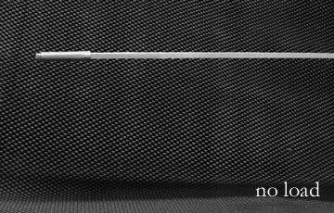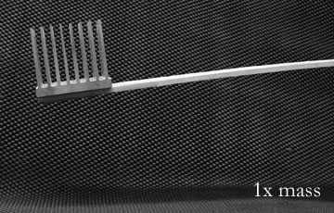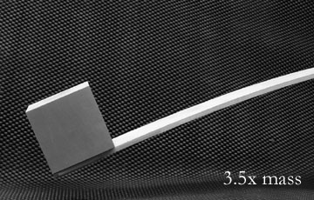
Support with no load. Support with 1x load. Support with 3.5x load.

Dream’s CFSC™ and zeroDELTA™ thin-featured lightweight mirrors (3-6x lighter than conventional mirrors) make a perfect combination and are athermal to each other. Dream’s zeroDELTA™ thin-featured lightweight mirrors follow ever-changing ambient air temperature hundreds of times faster than traditional mirrors. The goal for any optic is to be within +0.1°C to –0.2°C of the ambient temperature. This is a very small target to hit, but becomes far more challenging when ambient temperature is ever-changing.

Dream’s choices over the last two decades have been based on form following function. Every aspect and every detail are intentionally chosen, based on over 25 years of research. Dream’s technologies provide industry leading all-sky & all-temperature performance. The instruments stay aligned and focused, regardless of the instrument angle. Due to the high-stiffness and athermal nature of our instruments, it also means they maintain that performance year after year. This is one of many reasons they have the lowest maintenance & highest throughput.

Evolution & Perspective –
In 1928 G.W. Ritchey wrote, “We shall look back and see how inefficient, how primitive it was to work with thick, solid mirrors, obsolete mirror-curves, … ”¹

Ritchey began experimenting with lightweight mirrors on or before 1917. Ritchey was much more than an optical designer and optician. He designed and made his own polishing machines, cooled his telescope(s) during the day, as well as taking long exposures at night using photographic glass plates. He ground and polished those glass plates to match the best fit radius of the specific 2-mirror Ritchey-Chrétien telescope he was using at the time. He consistently used 0.5m and 0.6m telescopes to out-resolve telescopes of his time that were 1-1.5m in aperture.

A century ago Ritchey discussed numerous “refinements” in optics & mechanics that improved the performance of telescopes. His critics often claimed that his “refinements were too technical, and especially too laborious” ² to be practical. This is because most are unfamiliar with the high number of factors that are degrading the performance of their optical system and most are living with errors that are fully within their control. Limited knowledge (ignorance) leads to the Dunning-Kruger Effect. No one can know everything, but we can all know more.
Most who use opto-mechanical systems requiring front-surface mirrors are unfamiliar with lightweight mirrors and their myriad of advantages. Those who are familiar often describe their relationship with lightweight mirrors as tumultuous. This is because traditional extreme lightweight mirrors force the use of expensive deterministic finishing, or are difficult to finish properly with conventional methods without producing excess print through.

Too many believe the performance they achieve is limited not by the instrument but by the atmosphere. The truth is that it is exceptionally rare to find an instrument that is not being degraded by numerous errors, which are in fact very much within our control and originating in the telescope.

Regardless of the level of optical metrology test data for each “naked” optic, such test data is only a small fraction of the whole story. In fact how each optic is supported and tested is, by itself, a broad and deep topic, which touches at least three main areas: optics, mechanics and thermodynamics. Things as innocuous as the placement of a computer monitor relative to the interferometer, can have an affect on the “data.” In actual high-performance optics, not empty rhetoric, optical metrology of an individual surface is the burden of minimizing uncertainty in the data; a search for the truth. There is no one piece of test equipment that will provide 100% certainty.

If a another person with a 400mm telescope that uses solid mirrors stiffens some aspect of the instrument, their full instrument test might not show any improvement. If the person knows nothing about thermodynamics and material science, then their conclusion is that the “refinement” was pointless and that their telescope was already performing at the “highest quality” level it could. The performance limiter must be the atmosphere, right?

Dealing with thermal mass directly & thoroughly will more than likely make the “refinements” to the structure’s stiffness detectable. This will expose far more errors, like the back focus of the corrective optics needs to be optimized to a finer level. Regardless of the level of expertise and skill, no birdwatcher in the world can hear the call of a bird over the roar of a jet engine. Once the engine is turned off, that’s when the real work and fun begins. This is similar to putting on your first pair of glasses and realizing just how bad your sight was before glasses.

Dream’s optimized technologies combine to create a paradigm shift, but it does have historic reference.

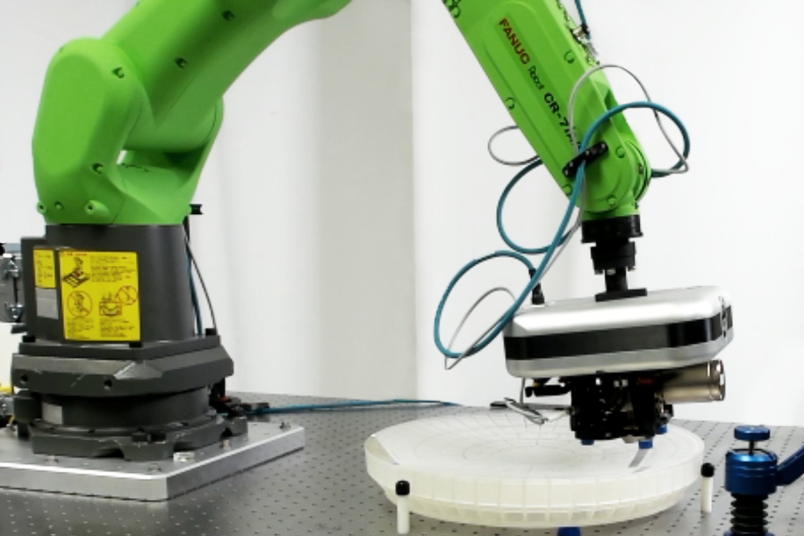
Outside Dream: 0.4m f1.376 zeroDELTA™ mirror being RMS surface roughness tested
with a 4D Technology NanoCam HD on a robot arm. Dream averages 6-9Å RMS surface roughness.

The 0.4m zeroDELTA™ mirror is 6 times lighter in aerial density than Hubble Space Telescope’s M1.

Maximum feature thickness is 3.175mm thick or the thermal equivalent of a 19.2mm diameter solid mirror with a 6:1 aspect ratio.

¹ The Journal Of The Royal Astronomical Society Of Canada, Vol. XXII, No. 9, November 1928.
http://adsabs.harvard.edu/full/1928JRASC..22..359R

² The Journal Of The Royal Astronomical Society Of Canada, Vol. XXII, No. 6, July-August 1928.
http://adsabs.harvard.edu/full/1928JRASC..22..207R

Copyright Dream Telescopes & Acc., Inc. - www.dreamscopes.com Nazareth, PA, USA (610) 360-7874 info@dreamscopes.com

