Optics - The Series
The Realities of Star Testing a Telescope

Shane Santi – President
Dream Telescopes & Accessories, Inc.
Copyright 2017 – v4

Star testing is a traditional method for qualitatively testing the performance of a telescope. It can be done visually with an eyepiece, direct digital imaging or digital imaging using eyepiece projection.

The use of a digital camera has numerous advantages over visual observations. Humans are subjective, which makes one person’s evaluation different from another. Humans also have a vested interest in their own telescope, which leads to bias. Many digital cameras use shutterspeeds that are roughly 3x faster than human vision. Digital images also allow detailed comparisons at a level that is difficult to impossible to achieve using vision and memory alone.

If you wish to define the quality of your system as best as possible, then there are two fundamentals that must be strictly adhered to in star testing. It cannot be emphasized enough how important both of these factors are;
- Regardless of whether star testing is done visually or with a digital camera it is imperative that the star be placed as close to the center of the optical axis as possible. Otherwise inherent off-axis aberrations will influence the views and therefore the conclusions.
- Both the at-focus location and the distance from that at-focus location need to be known to a very tight tolerance.

The smaller the errors claimed in the system, the tighter the tolerances for become for centration and focus when properly conducting a star test. It becomes quickly apparent that claiming system performance of say L/8 PV wavefront (wf) while using a manual focuser and human vision, with no means of centering the eye and no accurate method to quantify focus movements, is just as possible as walking on water. Such claims are simply bad science. The two factors above are two of many reasons why there can be such a large discrepancy in the evaluation of a telescope while using the star test.

This paper will show that the exact distance from focus, combinations of different errors, etc., can all influence the views and therefore the assessment of the system. Every simulated image in this paper assumes the star is perfectly centered. Even with digital imaging this is rarely true.

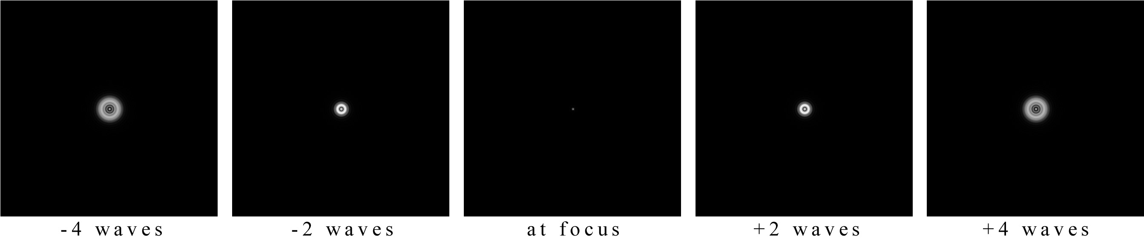
Fig. 1: Through focus views of a 30% obscuration telescope with zero errors.

Fig. 1 & Fig. 2 show simulated views of a perfect system that has a 30% obscuration. The center box is the at-focus position. This was enlarged 4x larger in Fig. 2 than in Fig. 1. Fig. 1 & 2 differ only in the distance from at-focus, called out in waves under each box.
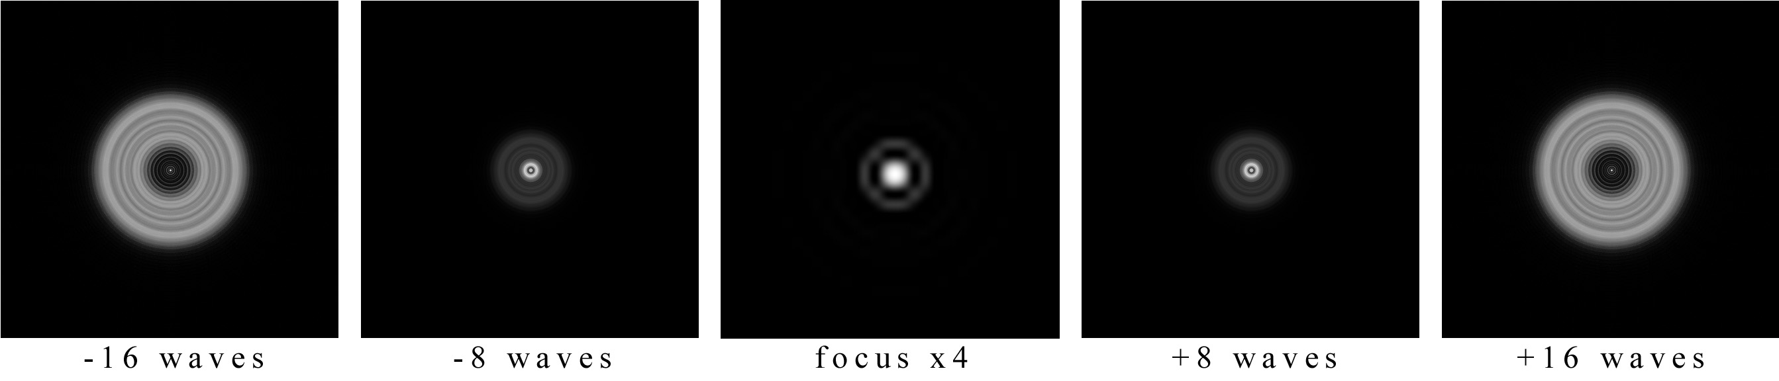
Fig. 2: Farther away from through focus views of a 30% obscuration telescope with zero errors.

For a 24” f5 Newtonian telescope Fig. 1’s at-focus view would require a 3.1mm eyepiece operating at 1015x. To achieve the at-focus view shown in Fig. 2 would require a 0.8mm eyepiece operating at 3863x, which is unrealistic for numerous reasons.

Chart 1 shows the waves used in Fig. 1 and Fig. 2 converted to physical distances from at-focus for a f5 system.

2 waves 4 waves 8 waves 16 waves
0.009“ (0.22mm) 0.017” (0.44mm) 0.035” (0.88mm) 0.069” (1.67mm)
Chart 1: Waves converted to distance from focus for a f5 system.

How quickly a star increases in diameter as the distance from focus increases is affected by many factors. If we zero out all alignment, all thermal, all optical surface(s) errors, etc., then the f-ratio and wavelength are by far the largest drivers for the size of the out of focus star. The diameter of the optic has a very small affect on the out of focus star diameter and is therefore ignored in this paper. This paper uses 550nm wavelength light for all data.

For a given distance from at-focus, faster f-ratio systems (f2, f2.8, etc.) will show a larger out of focus star than slower f-ratio (f8, f11, etc.) systems. This means the same distance from at-focus will produce different size stars for different f-ratios. This makes knowing exactly where focus is at and how far the current position is from at-focus, both keenly important if one wishes to roughly estimate the quality of the system using the star test; a qualitative, not quantitative test. Remember, both the at-focus position and the distance from that position need to be known to a high level of accuracy. Failure to measure these precisely will produce results with high uncertainty, because the distance errors are tainting the results, often by large amounts.

As the f-number gets lower (faster), the depth of focus decreases, which is illustrated in Chart 2.

f-ratio depth of focus change from f2 change from f8
2 0.0004” (10.7µm) 1 -16x
2.8 0.0008” (21.0µm) 1.96x -8.18x
4 0.0017” (42.9µm) 4x -4x
5.6 0.0033” (84.2µm) 7.87x -2.04x
8 0.0068” (171.8µm) 16x 1
11 0.0128” (324.8µm) 30.36x 1.89x
16 0.0271” (687.1µm) 64x 4x
Chart 2: Influence of f-ratio on depth of focus.

A faster f-ratio telescope, say f4, will “snap” into focus more distinctly, because of the influence of the depth of focus of that faster system. A f11 telescope will have a much broader focus and therefore does not snap into focus like the f4 system. From Chart 2 we can see that the f11 system will have a depth of focus nearly eight times larger than the f4 system.

Judging the performance of an optical system solely by how quickly it snaps into focus is therefore not a judge of performance at all. Two different f-ratio systems can have the same optical quality but the faster system snaps into focus “better.” It is incorrect to conclude that the faster system, because it snapped into focus, is higher in quality. Conversely, the faster system could be slightly lower in quality but because it still snaps into focus better, it can fool the viewer into a false conclusion.

Even when comparing two identical f-ratio telescopes there are a host of additional variables that can prevent a proper comparison. Comparing them on two different nights is an obvious variable one should avoid, since seeing could be wildly different. Whether both telescopes are “fully” equalized is another large variable. Judging the two telescopes based on snap-focus is highly subjective as well, relying on memory, which can easily play tricks on the mind. For all of these reasons “snap-focus” is a poor method for judging the performance of a system.

Chart 2 illustrates the depth of focus for full photographic f-stops. The f5 system has a depth of focus of 0.0026” (0.067mm or 67.1µm). Chart 1 showed that the 2 waves position for the f5 system was 0.009” (0.22mm) from at-focus. In reality views at this 2 waves location would be extremely difficult to obtain, for numerous mechanical and thermal reasons.

It is important to note that if a manual focuser is used for star testing and the distance from at-focus is therefore unknown to a tight tolerance, then conclusions related to PV wf performance of the system will have high to extremely high uncertainty. In order to properly compare views and therefore to properly use the star test, the focuser positions also have to be the same distance on either side of at-focus. Although the star test has been around for centuries, the most who use it are not following basic guidelines to keep uncertainty in check.

Even if the real world allowed viewing the 2 waves position, being able to position the focuser to mirrored locations intra and extra becomes difficult to impossible for the average manual focuser when the axial movements of the focuser need to be 0.009” (0.22mm); 2 waves location for f5 system. If we want to be within +/-10% of that 0.009” from at-focus, then the focuser’s movements need to be known to +/-0.0009” (+/-0.022mm). If we want to be within +/-5%, then cut the numbers in half. They are just numbers on paper but in reality they are very small movements that are impossible to accomplish by hand using a manual focuser.

If we translate these numbers into the 8 waves location for the f5 system, then we would be 0.035” (0.88mm) from at-focus, requiring the focuser’s movements to be known to +/-0.0035” (0.088mm or 88µm), to achieve +/-10% of where we desire to be. If the user makes no attempt to truly quantify the movement of the focuser, then everything is “easy.” An ostrich burying its head in the sand is also easy but has no value in honestly evaluating a telescope.

Any of the simulated views in this paper can also be used to show the views for a f3 system. However, those views are much closer to at-focus using the f3 system than for a f5 system. Chart 3 shows the conversion of waves to distance from at-focus for a f3 system. When compared to the f5 system the f3 system is roughly three times closer to the at-focus position in order to obtain 2, 4, 8 and 16 waves views. This means all focuser locations and tolerances just mentioned in the previous paragraphs for the f5 system now become three times more difficult to achieve. In order to be where we want for the 8 waves location, to within +/-10%, we would need to be able to move the focuser by +/-0.0012” (+/-0.029mm or +/-29µm) for this f3 system. This puts the difficulty of f3 into perspective and is a further example of why 2-4 waves, and often slightly greater locations, are difficult to impossible to achieve in the real world. It also shows that claims of very high quality in the system require tolerances that are generally impossible to achieve in reality, even for a stiff, well-made electronic focuser, let alone manual focus.

2 waves 4 waves 8 waves 16 waves
0.003” (0.080mm) 0.006” (0.159mm) 0.013” (0.317mm) 0.025” (0.633mm)
Chart 3: Waves converted to distance from focus for a f3 system.

Overly clean, simulated views at the 2-3 waves locations can show all kinds of subtle errors that seem easy to notice, in a simulation. We can enlarge those simulated views infinitely. However, this is not reality. Reality has the mechanical tolerance issues mentioned previously, as well as additional structural and thermal issues. Also remember that the star needs to stay centered in the field as well.

A digital camera, which can be a cheap web cam, in combination with a precision electronic focuser, can take digital images and more appropriately quantify the distance from at-focus. However, this only takes care of the focuser and imaging side of things. It does nothing for the host of other issues that fight us from obtaining views at only 2-3 waves from focus.

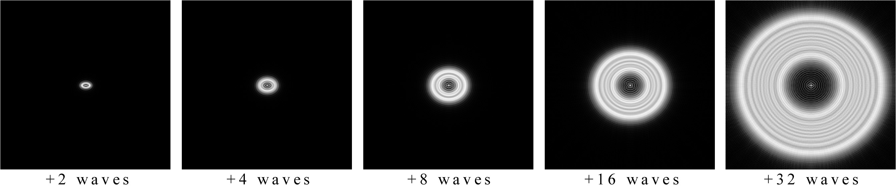
Fig. 3: Extra-focus simulated views of 30% obscuration
system with 550nm PV wf (1 full wave) of astigmatism.

Fig. 3 shows the simulated views when 550nm (1 full wave) of PV wf astigmatism is added. This is 1 full wave of error at 550nm wavelength light. The views shown are only extra-focus (outside focus) views, in order to show five consecutive distances from at-focus. These views show that very close to at-focus the asymmetry caused by astigmatism is far easier to notice, as an oval. This is because closer to at-focus is more sensitive. Conversely farther away from at-focus is less sensitive. As we get farther and farther out in Fig. 3, the oval-shaped fingerprint of astigmatism becomes more and more round, which makes it harder to detect. The distance from at focus sensitivity to showing errors is true for many types of errors, not just astigmatism. Even in these simulated views that have no other issues, like seeing or tilt errors of the optics, it becomes difficult to distinguish the oval shape starting at or before +/-16 waves from at-focus.

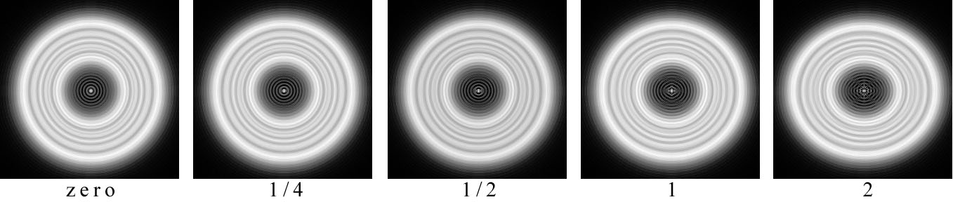
Fig. 4: 30% obscuration system, 20 waves extra focus with zero,
¼, ½, 1 and 2 waves of astigmatism (PV wf).

Fig. 4 shows cropped in, simulated views at 20 waves of extra focus, for zero, ¼, ½, 1 and 2 waves of astigmatism; 0, 137.5nm, 275nm, 550nm & 1100nm PV wf respectively. The views show the slight shape change of the out of focus star from differing amounts of astigmatism. Even with these views side by side it is extremely difficult to tell the difference between no astigmatism and ½ or even 1 full wave. Remember, this is an unrealistic, overly perfect view that has no alignment, no distance, no centration, no thermal, etc., errors in the system. As soon as you add any of those, the views become even more indistinguishable from each other. Plus in real-world testing you are not seeing side by side, easier to detect the differences, views like Fig. 4 shows.

All of the previous simulations were done without any optical alignment errors in the system, without any thermal errors (system and atmosphere), with the star perfectly centered in the optical axis and with focus positions perfectly placed. It is therefore still an unrealistic view, yet it conveys what anyone who has conducted this test has seen in person; the farther away from at-focus, the less sensitive the test.

Errors exist in all systems. The errors can come from; optical, mechanical, thermal, etc., even for space telescopes. Systems always have a combination of more fixed errors, changing on a small scale, as well as dynamic errors, which can change at any number of scales. Dynamic errors are influenced by gravity (telescope angle change) and temperature, to name two of many. A 24” telescope mirror that moves around is anything but a static optical figure. Gravity, the mirror mount and other factors are changing the shape of that optical surface. Modern engineering analysis and Gen V high-resolution interferometry both show that the optical surface is not one fixed shape in cases like this.

Fig. 5 shows simulated views of the 30% obscuration system with 1 wave of astigmatism (PV wf) that are more realistic, accounting for one type of thermal issue; mirror seeing.

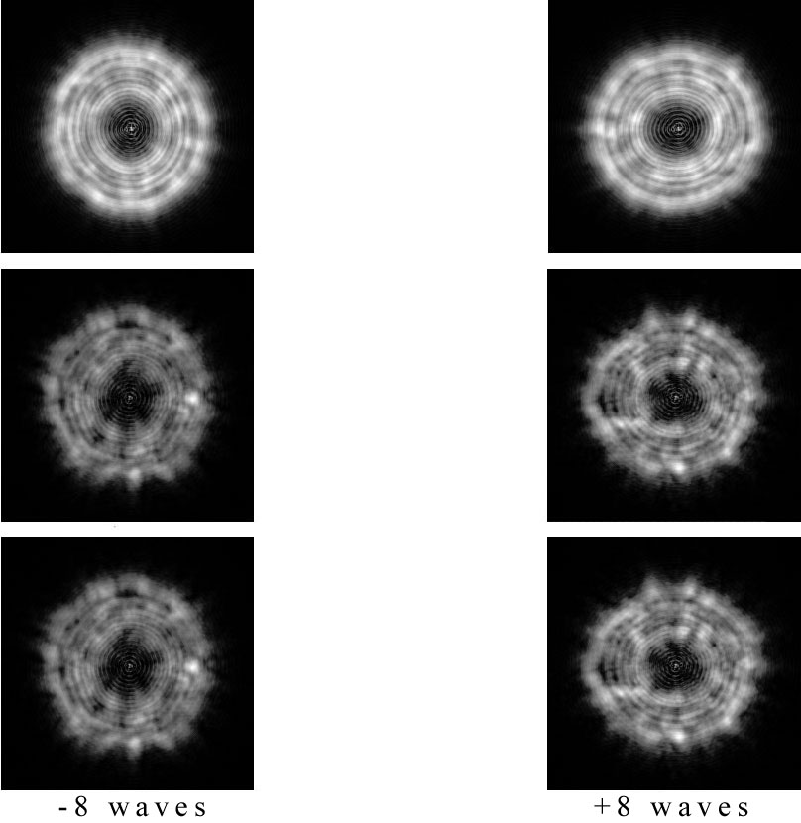
Fig. 5: 30% obscuration, 1 wave of astigmatism, simulated for three different levels of seeing.

Fig. 5 illustrates progressively worse seeing from top (better) to bottom (worse but still fairly good). Even in the top view, with the least amount of seeing, it is evident that when the star is viewed alone at each intra and extra position, it would be nearly impossible to tell the difference between the star shapes. One full wave of astigmatism is difficult to detect in the views shown in Fig. 5. Even if an observer believes they have abnormally keen eyesight and a superb memory, at some scale the errors become invisible.
The views in the real world will “boil” to one degree or another; from one or both mirror(s) seeing and atmospheric seeing. The views are not static like the simulated views in Fig. 5. The 254 frame video shown at the link here illustrates digital imaging with an exposure that is 3x faster than average human vision. It illustrates the non-static views one typically encounters in the real world.

In star testing, regions that might appear to have slightly more light than others can move around, due to numerous seeing issues. Also notice that the views shown in Fig. 5 are 8 waves from at-focus. For the f5 system this is a position 0.035” (0.88mm) from at-focus. But for the f3 system 8 waves is only 0.013” (0.317mm) from at-focus.

Numerous errors can combine to counteract the visual asymmetry that might otherwise just be noticeable from astigmatism. Both tilt errors in the system and allowing the star to go off-axis slightly can improve (compensate) or worsen (additive) the view seen away from at-focus. A great many variables influence the views seen and therefore taint how the viewer is judging the system. This is why this test has been and always will be qualitative, not quantitative.

Fig. 4 (near the top of page 4) shows the simulated and ideal views when 1 wave of astigmatism is added to the system, without any other errors. Fig. 6 shows what that same error looks like when we also add in two low-level thermal issues. It makes differences even more difficult to detect, especially when one considers the views in these figures are static, side-by-side and the at-focus distances are perfect.

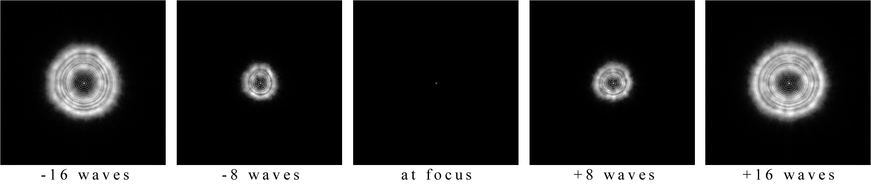
Fig. 6: 30% obscuration system, 1 wave PV wf astigmatism & small amounts of seeing-related issues.

Fig. 6 makes it clear that claims of “L/20” or better are quite absurd. Seeing them on this page nearly side by side is wholly different than seeing them individually (visually), with time between viewing each one. Again, this assumes the star is perfectly centered, that both at-focus and distance from at-focus are all known perfectly, that there is no alignment error in the optical system, that the figure of the mirror is stable, etc., etc.

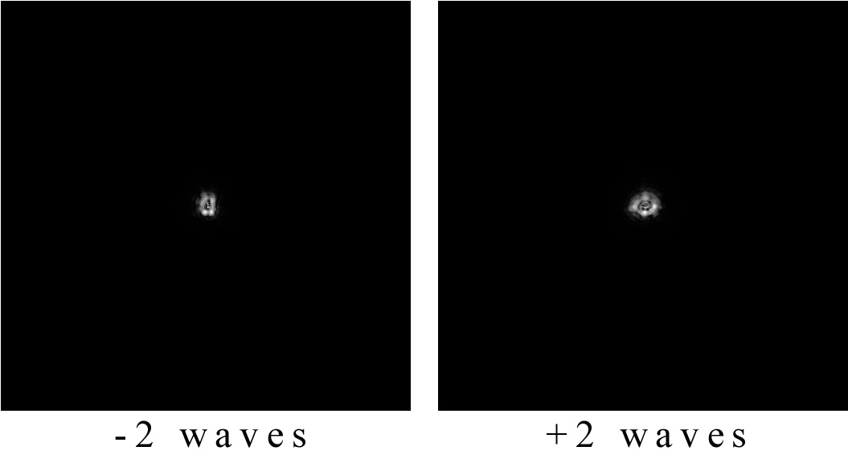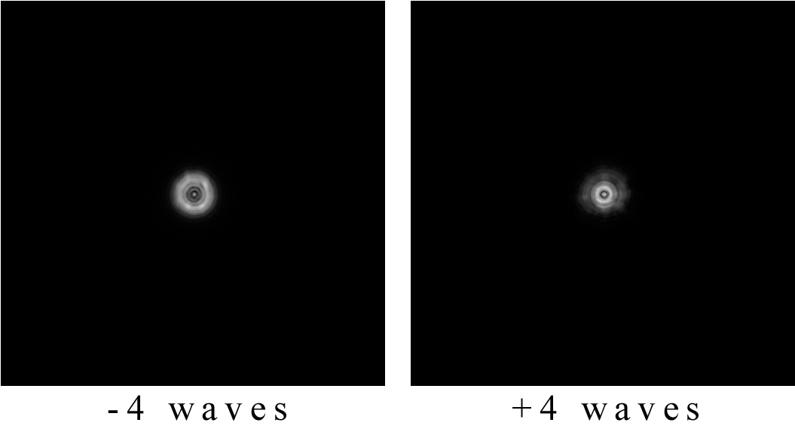
Fig. 7: 30% obscuration system, 1 wave PV wf astigmatism & small amounts of seeing-related issues.

Fig. 7 shows the 2 and 4 waves from at-focus positions, to show that the star still appears to be generally round, even though we know astigmatism should be making it oval in shape. Keep in mind, this is 1 full wave of astigmatism and in Fig. 7 is at a distance from at-focus that is nearly impossible to achieve.

One thing to notice about the intra and extra focus images in Fig. 6 & Fig. 7 is that there is a subtle size difference between the intra and extra at each specific distance from at-focus. Again, this is an idealistic view that is at a perfectly mirrored distance from at-focus, intra to extra. It would be extremely easy, even with a precision electronic focuser, to be just slightly farther away from at-focus with the –2 waves view by error (drive mechanics or from flexure in the system). This would make the star slightly larger in diameter than it would be with no distance error, which would make the two intra and extra views “match” each other in size, leading one to falsely conclude the system is better than it really is.

After seeing live views like that shown in Fig. 6 it would not be surprising to hear a person state the optical system is better than L/20, L/50, etc., PV wf. When in fact the system still has 1 full wave of error. This illustrates why the two fundamentals mentioned are so important. But they are the tip of the iceberg in terms of the ability of small variables to influence what is seen/recorded during a star test. Ignorance is not bliss.

Without knowing exactly how far the given live view(s) are from at-focus, the evaluation of the quality of the system, drawing conclusions through comparative means against simulated views, is far from accurate. In fact the misuse of these types of simulated images can lead one to believe the system is beyond diffraction-limited, when in fact it still has errors that are far greater than the diffraction-limit.

If the user can see a very slight hint of the oval shape, intra and extra focus, when they are 32+ waves from at-focus, the simulated views show that the error could be far, far larger than 550nm (PV wf). This is why knowing the distance from at-focus to a fairly high precision that itself (the distance) has high certainty, is a must if one wishes to estimate the PV wf quality of their system.

Coma is another non-symmetric error, like astigmatism, and is shown at 1 wave of error in Fig. 8. You can see it pushes the central obstruction shadow off to the side and makes one side of the out of focus star a little brighter than the other, at least in the 8 waves views. These anomalies are generally invisible in the 32 waves views.

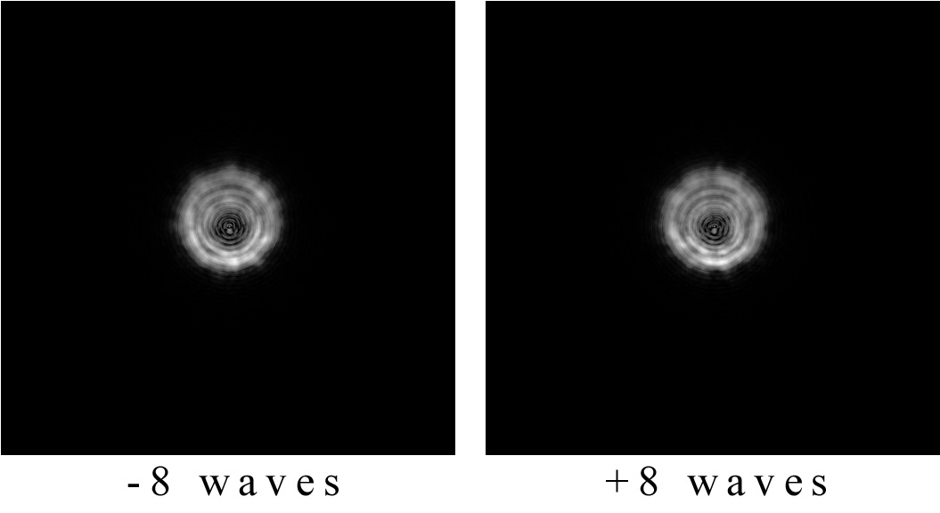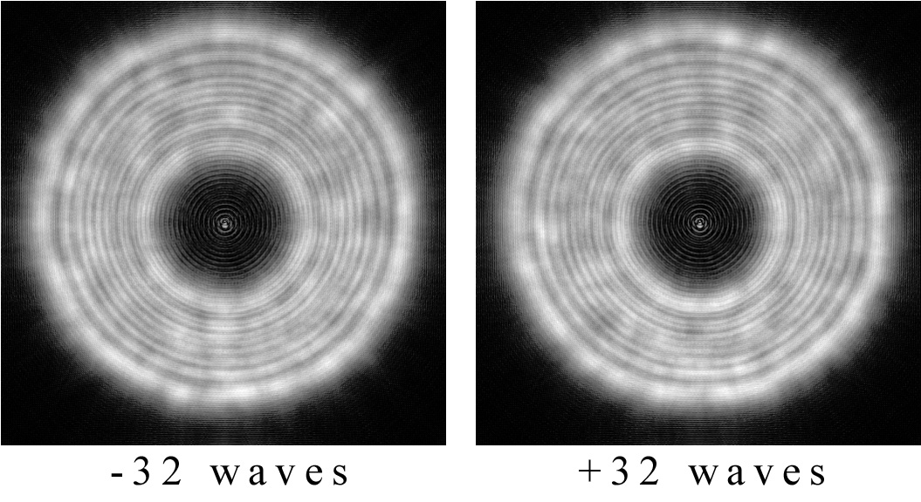
Fig. 8: 30% obscuration system with two errors; 1 wave of coma and quite good seeing.

Figure of revolution errors, spherical aberration being one, can make intra and extra views different in size and brightness. This is why it is so critical to know, to a high certainty, how far from at-focus the views are, since errors in distance from at-focus will enlarge or shrink the out of focus star, as well as mirroring them on either side of focus, to a high tolerance. Fig. 9 shows ½ wave of spherical aberration, as well as quite good seeing added in.

The smaller the errors claimed in the system, the tighter the tolerances get on everything during this qualitative evaluation. As depth of focus and distance from at-focus showed, it wouldn’t take much movement to get an intra or extra view to match in size.

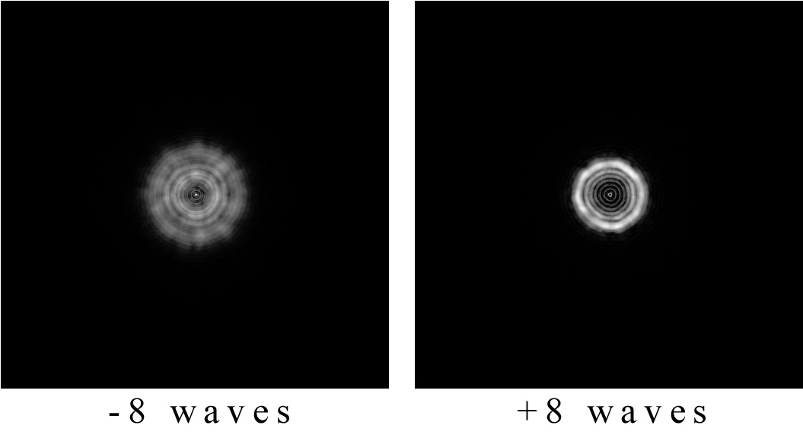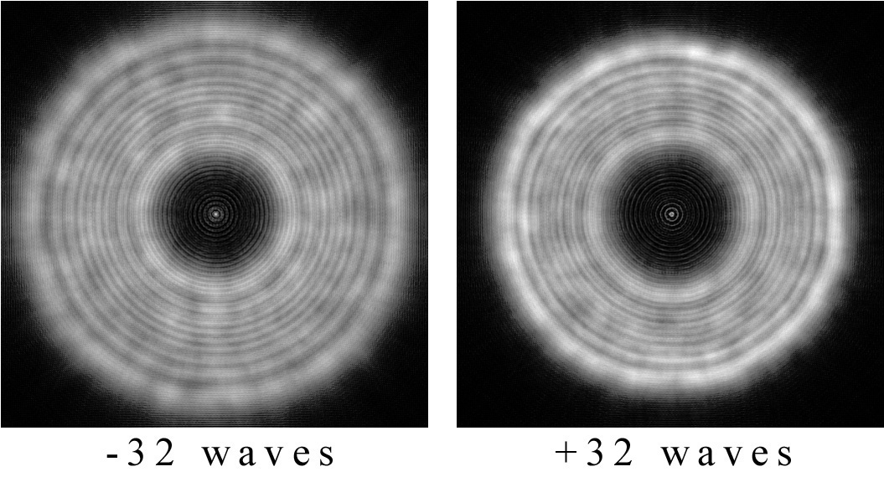
Fig. 9: 30% obscuration system; ½ wave of spherical aberration and quite good seeing.

No mirror has only one type of error remaining and no mirror has zero errors. Fig. 10 shows five different errors combined. Again, when the actual views are changing from numerous types of seeing, the views in Fig. 10 become indistinguishable from each other. During actual evaluation the views from the 8 waves position shown in Fig. 10 will appear quite good and quite similar to each other, even when a “perfect” electronic focuser is used.

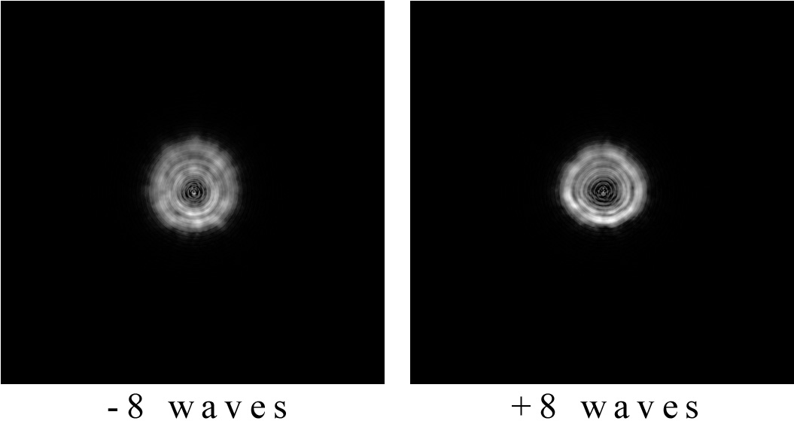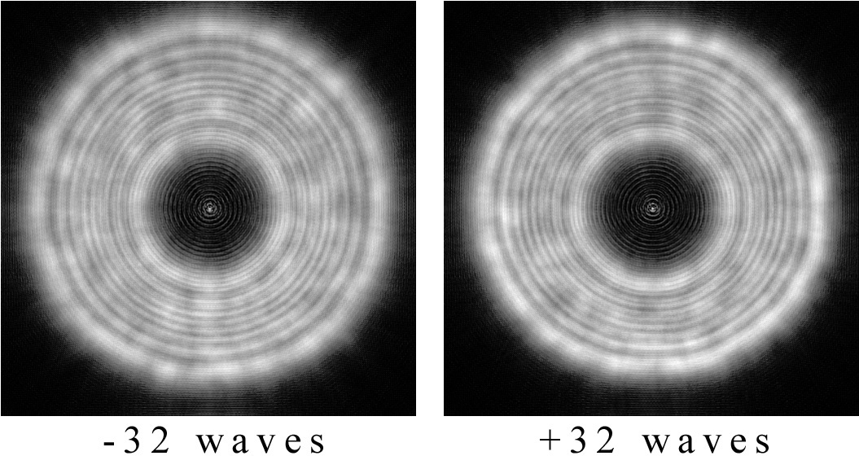
Fig. 10: 30% obscuration system; 0.5 wave of coma, 1 wave of astigmatism, ¼ wave of spherical aberration and two thermal errors.

All of the errors in the simulation for Fig. 10 are moderate to large in scale. As the error sizes decrease it becomes easier and easier to hide the remaining defects from view and therefore detection, leading one to believe the system is “perfect” or well past the diffraction-limit, which is defined as L/4 PV wf, L/14 RMS wf.

Fig. 11 shows the errors used in Fig. 10 but now the errors have been made smaller. The scale of the errors is written in the Fig. 11 description. Fig. 11 is shown without thermal distortion(s) to show how difficult it is to tell the difference between intra and extra focus views with the errors reduced to this level.

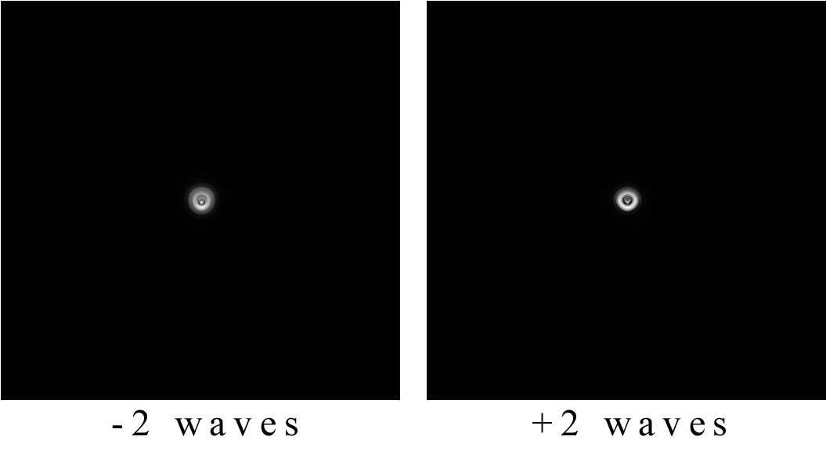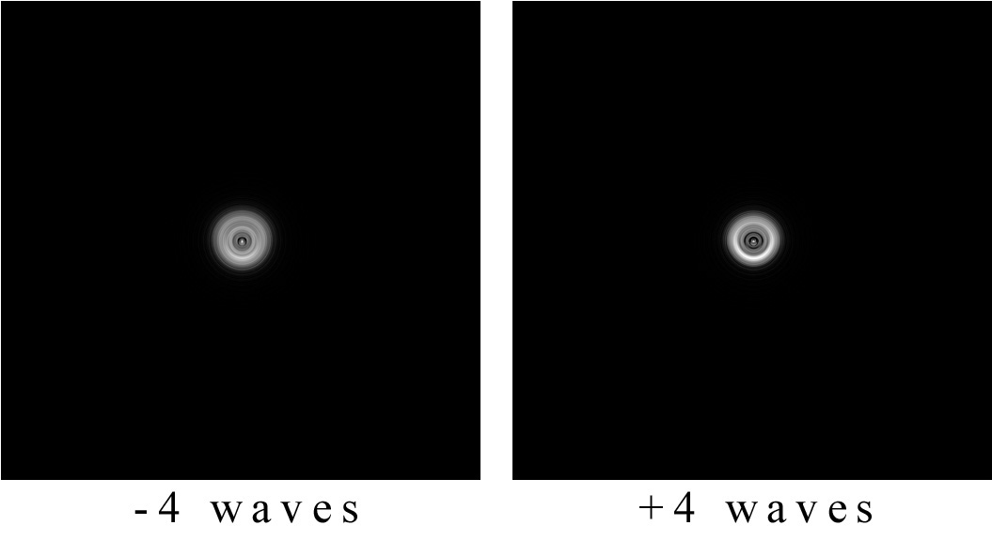
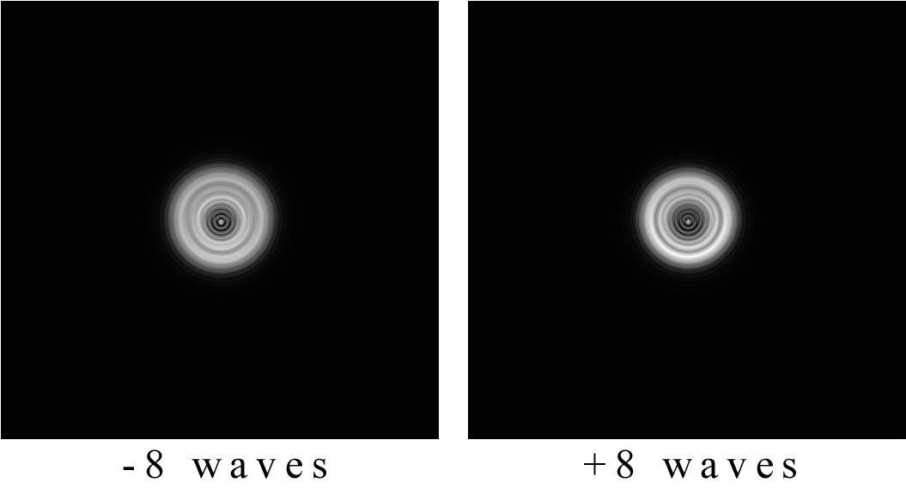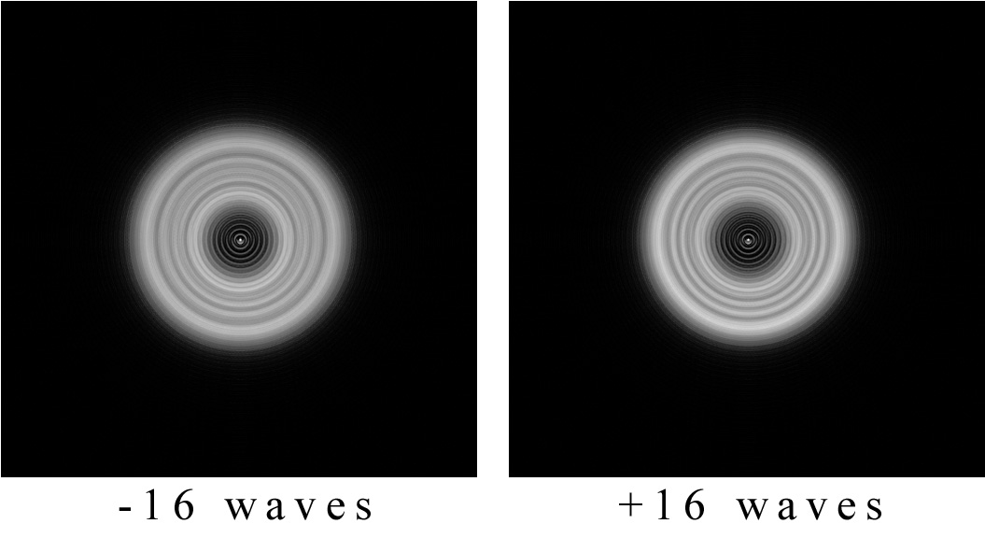
Fig. 11: 30% obscuration system; ¼ wave of coma, ¼ wave of astigmatism, 1/8 wave of spherical aberration, 1/8 wave of pinched optic and cleaner views than Fig. 12.

Remember, Fig. 11 is an idealized viewpoint because there is essentially no seeing, the images are side-by-side, distance from at-focus errors are zero, the star is always perfectly centered, etc., etc.

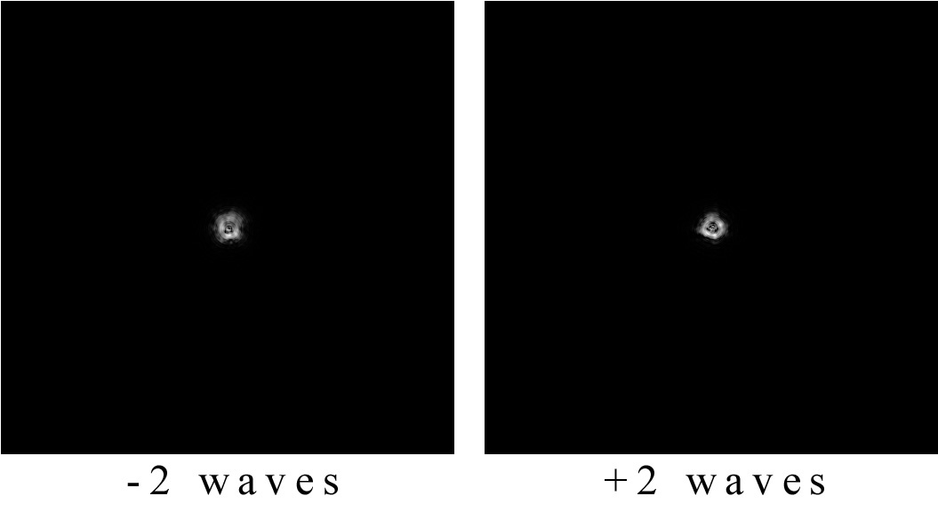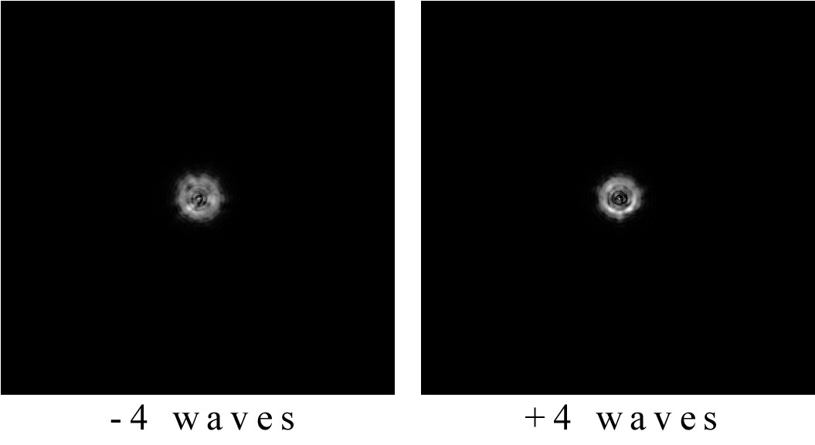

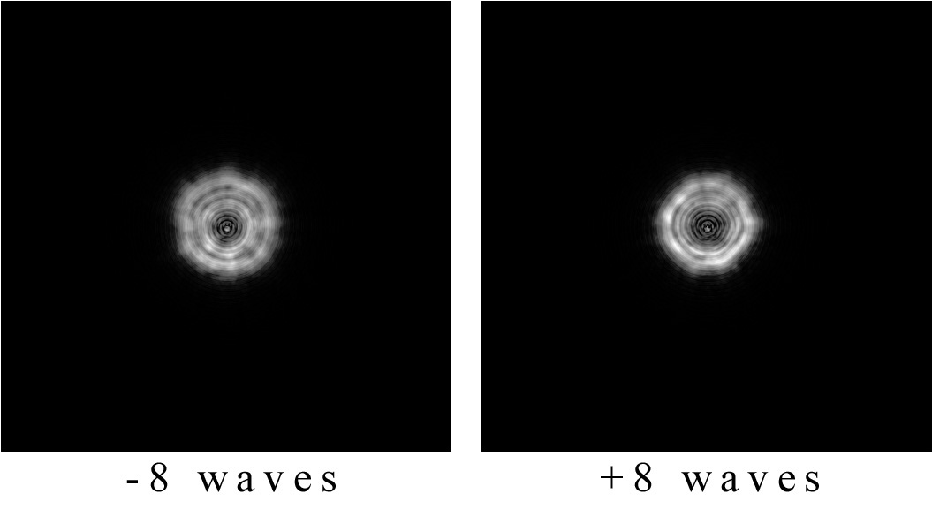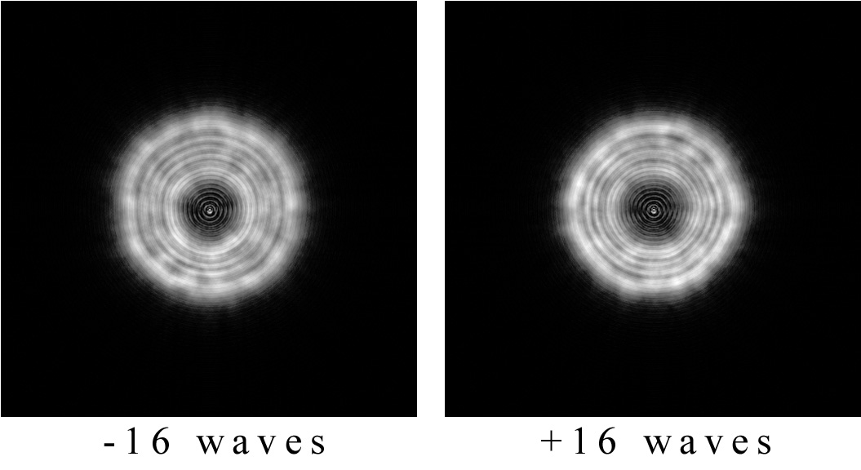
Fig. 12: 30% obscuration system; same errors as Fig. 11 but now with seeing added in for realism.

Fig. 12 shows more realistic views of the same errors used in Fig. 11. Remember, the views will change in reality as seeing influences them, unlike the static views above. The views become impossible to detect errors at this level.

Conclusion –
The two largest errors made during star testing are;
- being much farther away from at-focus than believed and,
- not being exactly the same distance from at-focus.

This paper has shown that both have a profound affect on the views seen. A person who believes they are at the 2 or 4 waves position but are actually 16-32 waves away from at-focus, might state and honestly believe that their system is L/10, L/20, etc., PV wf. They compare what they see in reality (while actually at 16-32 waves position) to simulated views that should be seen at the 2 or 4 waves position. The extensive simulations and information within this paper have shown why they have come to that conclusion. The tolerances for knowing exactly where both at-focus and distance from at-focus on either side are incredibly tight for the 2 or 4 waves position. In some cases the tolerances are tight all the way through the 8 waves position. The farther from at-focus, the better the out of focus star appears. This leads to a false conclusion that the system has much, much smaller errors than it does in reality.

This will not stop some from believing their system is “perfect.” That’s part of human nature. In some cases no amount of information will persuade them to believe otherwise. Some with a keen eye may have noticed that the hords of telescopes that are “perfect” show differences. They may have noticed that optical alignment shows differences as the telescope angle changes; flexure. Flexure also causes focus shifts. They may have noticed one of the mirrors in the system shows pinching at certain telescope angles but far less at others. This paper has shed light on why all of these assessments can co-exist.

For those who want a more objective assessment of their telescope, in the most unbiased way, this paper has laid out the fundamentals to follow and why those fundamentals are so critical during star testing. A good telescope is one that gets used. Don’t forget to use the telescope at-focus.

For another method of assessing the quality of a telescope, please review this article that used NASA images of the Moon to determine telescope resolution.

Copyright 2017 Dream Telescopes & Acc., Inc. - www.dreamscopes.com

