
The 30-year Knowledge Series
Shane Santi – Founder & President
v5, August 13th, 2023 - Copyright Dream Aerospace Systems


How To – Understanding Off-Axis Performance of Paraboloidal Mirrors

The theoretical limitations of a given optical design can be used to evaluate the performance of different variants of the design, and whether additional optics should be used to improve the performance of that design. This type of initial evaluation is based on optical physics. It assumes a perfect optical surface, a perfect support, no thermal, alignment or focus errors, etc. This article will quantify and compare different optical design parameters, evaluating those changes one variable at a time.

The purpose of most Dream articles is to educate buyers by breaking optics into simple, understandable segments. Understanding optics to a slightly deeper level will help determine what statements can and cannot exist in reality.

Focal Plane: on-axis versus off-axis
On-axis is one location; the exact center of the field, which is generally the center of the eyepiece or detector. As soon as we go away from the center of the field, it’s considered off-axis. Because of this, off-axis has to be defined. Saying something is off-axis without defining how far off-axis is akin to saying the stars are “pinpoint,” without quantifying what “pinpoint” means.

The most common and long-standing mirror-based optical designs are; Newtonian and the Cassegrain variations. For Cassegrains the three most common are; Classical, Ritchey-Chrétien and Dall-Kirkham. There can be a great many variations of each but in these three classic forms their on-axis performance is diffraction-limited. Again, on paper, when all mechanical and thermal errors are zero, which is not reality. However, it is still useful to initial evaluate performance while leaving all errors at zero.

This article will evaluate the performance of the paraboloidal primary mirror alone. This is the mirror found in true Newtonian and Classical Cassegrain, as well as some prime focus (primary mirror only, no secondary mirror) and custom variations of Cassegrains.

Fig. 1 shows the inherent performance of a 0.25m f5 paraboloidal mirror with a 10mm field diameter (5mm off-axis). The black circles depict the airy diameter or the diffraction-limited performance level. Regardless of the size of the field, airy diameter (for a given wavelength of light) is the same size across the field. Pink shows the shape of the spot at each given location. The on-axis performance of this mirror is diffraction-limited. The outer regions are dominated by coma; one of the inherent optical aberrations.

As you go closer to the center of the field, the spot sizes are smaller. This can be seen at the 12, 3, 6 and 9 o’clock positions. Those four locations have spots that are smaller than the four corners, because they are a little closer to the center of the field.

You might be wondering why the spot diagram is showing such large and “ugly” off-axis spots. After all 2D drawings on-line and in books shows that a paraboloidal mirror corrects out the spherical aberration that occurs when we use the mirror with extended objects (objects at “infinity”), making all of the rays come to one diffraction-limited point. Yes, this is true. Unfortunately this is only true for on-axis. It is not true for off-axis.

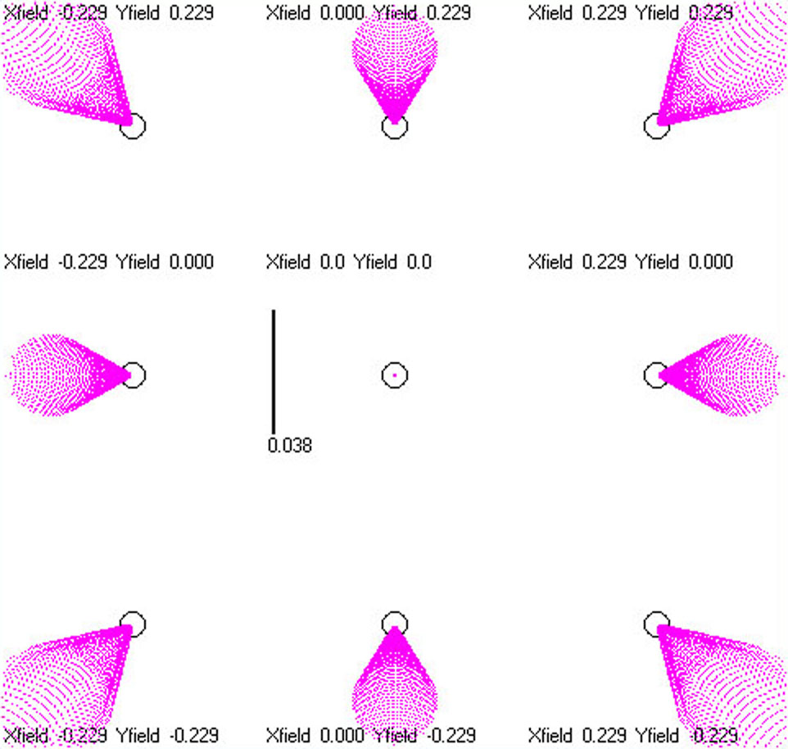

Fig. 1: Full field spot diagram of 0.25m f5, 10mm field diameter

Inherent Performance
The spot diagram is showing the theoretical performance of the given mirror, for a given field size. In this case without any corrective optics added to the mix. The information within this article will show that even fairly small fields and using f8 still does not produce a diffraction-limited full field. Always keep in mind that we are looking at the performance of the paraboloidal primary mirror alone, while zeroing all errors that occur in reality.

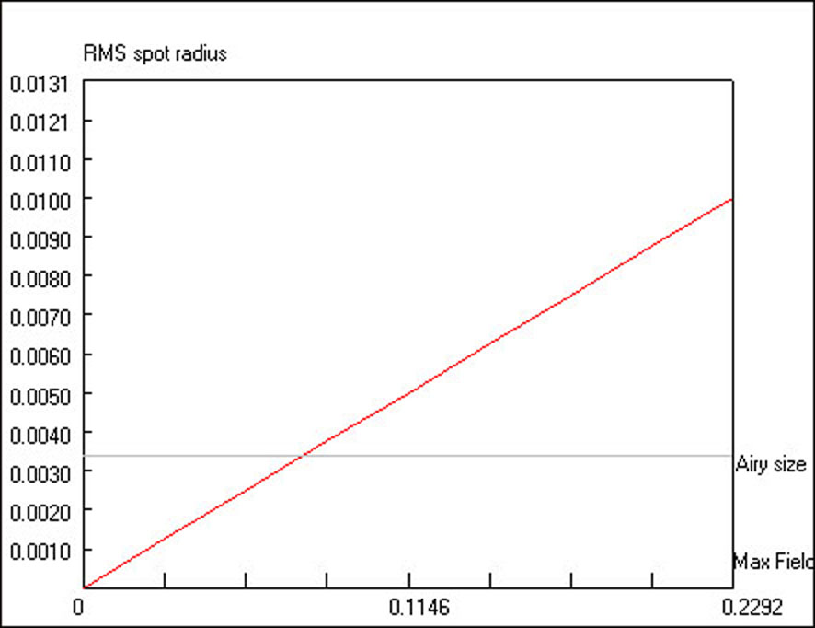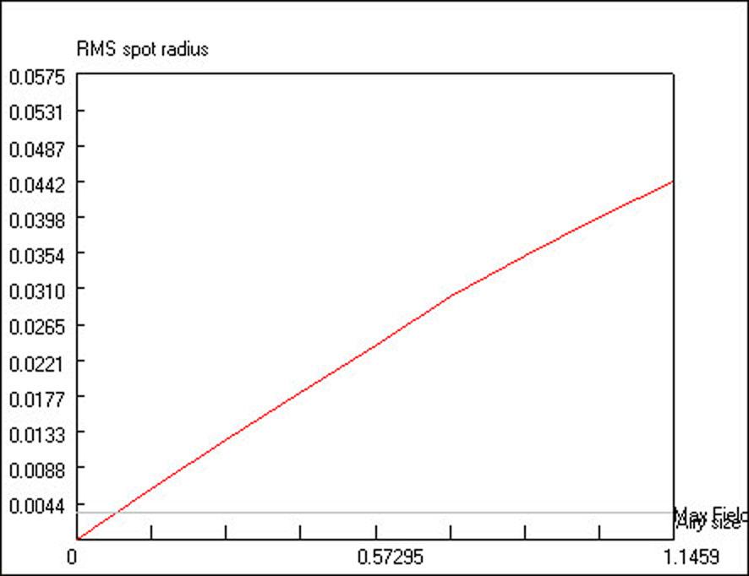

Fig. 2: Full field graph of 0.25m f5, 5mm off-axis Fig. 3: Full field graph of 0.25m f5, 25mm off-axis

Fig. 2 quantifies the spot sizes over the whole field used in Fig. 1. The left edge of Fig. 2 shows on-axis, 0 being the center of the field, and the right side is off-axis, 5mm from the center of the field. The red line represents the RMS spot radius size, which you can see is quite linear as it goes from on-axis to off-axis for a paraboloidal mirror. Fig. 2 represents the 10mm field diameter performance (5mm off-axis), while Fig. 3 shows the same mirror but now with a 50mm field diameter (25mm off-axis). The horizontal gray lines in Fig. 2 & 3 are the airy size and diffraction-limit. You can see that Fig. 2’s graph is diffraction-limited over the central ~35% of the field (~3.5mm focal plane diameter), while the rest of the field is not diffraction-limited. The edge of the 10mm diameter field has RMS spots that are 20 microns (µm) in diameter.

On nights of poor seeing, the 20µm spot sizes may not be detectable as comatic during visual use astronomy. However, a detector should be able to document the elongated, off-axis shapes because a 0.25m aperture at 550nm wavelength light has an angular resolution (diffraction-limited performance) of 0.554 arc-second. A detector using 3.76µm pixels has an image scale of 0.63 arc-second using a 0.25m f5 instrument.

If the installed performance was degraded 4x compared to the raw image scale (0.63 arc-second), this would equate to 2.52 arc-seconds on-sky installed performance, which is a star around 15.04µm in diameter. The comatic elongation of stars at the edge of the field is 33% larger than the 15µm (20µm/15µm), which should be detectable. If it is not, then the installed optical system has soft installed performance. For a primary mirror the diffraction-limit is λ/4 PV wavefront and L/14 RMS wavefront. If the 5mm off-axis star is 2.52 arc-seconds on the sky, then it means the system’s installed performance is 4.55x worse than the diffraction-limit. This is equivalent to a mirror finished to 1.14λ PV wavefront and λ/3.1 RMS wavefront.

The RMS spot size for the edge of the 50mm diameter field shown in Fig. 3 is 88.4µm in diameter. If the off-axis errors shown in Fig. 3 cannot be detected during visual use or in imaging, then the optical system is providing extremely soft installed performance. This would be the equivalent of a mirror finished to 5.04λ PV wavefront and 1.44λ RMS wavefront. It should be noted that the instrument is still collecting light and will still show something. Installed optical systems will typically show something. Low installed performance optical systems aren’t like a switch, where they show and do nothing. This can fool us into believing everything is working well, when in fact, things are extremely far from the diffraction-limit. This is why learning optics to slightly deeper levels can be so insightful and valuable.

Conversely, if a person believes their telescope is performing at or “beyond” the diffraction-limit, then they should be able to detect the off-axis comatic stars in Fig. 1 & Fig. 2. If coma cannot be detected, then the installed performance of the optical system is more than four times worse than the diffraction-limit.

Fig. 2 & Fig. 3 show that as we go farther off-axis aberrations inherent to the optical design will impact performance by an ever-increasing amount. This is true for all optical designs. How well the total system deals with the inherent aberrations is the real question. Often additional optics are added to deal with the poor off-axis performance, which is why those optics are called corrective optics. Quite often lenses are used as the corrective optics for the system.

Inherent optical design aberrations are based in optical physics. Spherical, astigmatism, coma, trefoil, etc., are some of the main optical aberrations. The errors that remain in the mirror from finishing the physical surface are added to the inherent aberrations of the optical design. Polishing errors can only degrade the inherent optical design aberrations further. Polishing cannot change or decrease inherent optical design aberrations.

Although we can physically polish in errors that have the same names, coma, for example, there is a distinct difference between optical design aberrations and errors that remain in the surface of the front-surface optical mirror. Doing additional design work can compensate for the inherent optical design aberrations of the mirror. In the case of the Newtonian we can add a coma corrector to decrease the size of the off-axis, comatic stars. Each lens has two optical surfaces, as well as thickness and refractive index. All of these provide additional design freedoms that the single surface paraboloidal mirror alone cannot offer.

Field Diameter
The field stop inside an eyepiece will limit how large of a field diameter is being used. Most eyepiece manufacturers provide the field stop diameters of their eyepieces. Use that information to gauge how large of a field diameter you are using with any given eyepiece. Field diameter should not be confused with Field Of View (FOV). Field diameter is a physical limitation at the eyepiece, whereas FOV is the amount of sky being viewed.

For imaging systems the field diameter is based on the size of the detector used. Specifically a circle traced onto the corners of the given detector. For a 37mm per side square detector this is 52mm in diameter. The largest current monolithic detector is 95mm per side. That’s a field diameter of roughly 135mm. Some projects use buttable detectors to create large focal plane arrays. These can be 600mm or larger in diameter for multi-meter class telescopes.

Correcting such large fields is a huge task. The faster the f-ratio and the larger the focal plane, the greater the off-axis spot size. These tend to grow at rather alarming rates, as we will see with further comparisons. The inherent optical design aberrations can be reduced to small amounts, through the use of additional optical surfaces.

Comparisons
Fig. 4 & Fig. 5 show spot diagrams for the Fig. 2 & Fig. 3 data, which showed 0.25 meter f5 mirror with 10mm and 50mm field diameters respectively. The magnification has been reduced so it is easier to see the off-axis spot sizes of the larger fields.

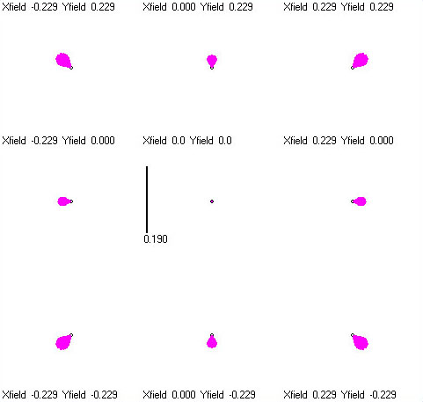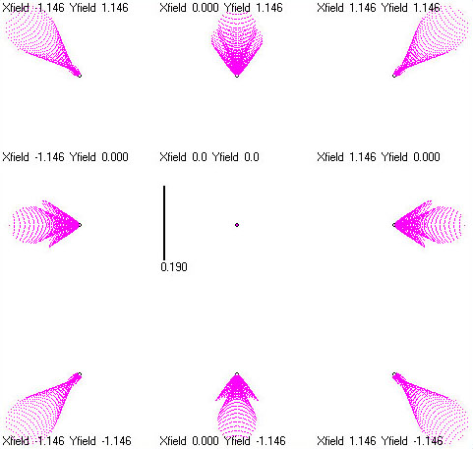

Fig. 4: Full Field of 0.25m f5, 10mm field diameter Fig. 5: Full Field of 0.25m f5, 50mm field diameter

Chart 1 puts numbers to the above graphic representations of the off-axis spots. The numbers below tell us the spot size at the edge of the given field, while comparing that to other field locations and the airy diameter.

Field Diameter RMS spot diameter Difference Compared to Airy Ø
10mm 20.0 microns baseline 3x larger
20mm 38.4 microns 1.92x larger 5.6x larger
30mm 57.6 microns 2.88x larger 8.5x larger
40mm 74.6 microns 3.73x larger 11x larger
50mm 88.4 microns 4.42x larger 13x larger

Chart 1 – influence of field diameter on off-axis RMS spot size (in diameter) for 0.25m f5

Fig. 6 shows the spot diagram view of the upper right corner of the five different field diameters listed in Chart 1. The number listed below each square tells how far off-axis that spot is located. The Difference column compares different distances off-axis to the baseline; 10mm field diameter.

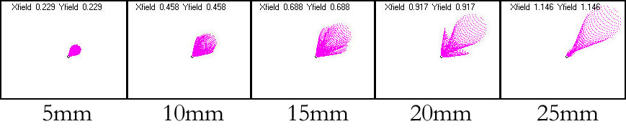
Fig. 6: 0.25m f5, off-axis spots for 10, 20, 30, 40 & 50mm field diameters

Fig. 7 below shows an enlarged view of the 5mm off-axis spot. Fig. 8 below shows an enlarged view of the 25mm off-axis spot. Both Fig. 7 & 7 spots go well outside the view shown. Compare the below views to the far left and far right views of the full spots, shown in Fig. 6, to get a sense of just how stretched the 25mm off-axis spot is compared to the 5mm off-axis spot. The airy diameter shown in all of these views is 6.8 microns.

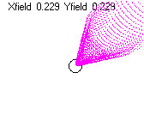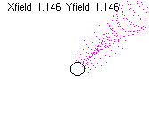
Fig. 7: 0.25m f5, 5mm off-axis Fig. 8: 0.25m f5, 25mm off-axis

It should immediately be apparent that even with the rather small field diameter shown in Fig. 7, using a fairly slow f-ratio mirror (f5), the off-axis performance spreads well outside the airy diameter/diffraction-limit. Chart 1 showed that the 5mm off-axis spot has an RMS spot diameter of 20.0 microns, which is nearly three times larger than the airy diameter. The 25mm off-axis spot has an RMS spot diameter of 88.4 microns or 13 times larger than the airy diameter. Again, this information can be used to determine whether a system is performing at the diffraction-limit or not. In the real world very few systems are operating at the diffraction-limit. In order to approach the diffraction-limit requires intense scrutiny of the optical system, the mechanical system and thermal issues that abound in optical systems. It’s difficult to impress just how much effort this can take.

F-ratio’s Influence On Spot Size

f-ratio Field Diameter RMS spot diameter Difference Airy & Difference
f2.0 20mm 252.8 microns baseline 2.8µm & 90.3x larger
f2.8 20mm 128.2 microns 2x smaller 3.8 & 33.7x
f4.0 20mm 62.8 microns 4x smaller 5.4 & 11.6x
f5.6 20mm 31.4 microns 8x smaller 7.6 & 4.1x
f8.0 20mm 15.4 microns 16x smaller 10.8 & 1.4x

Chart 2 – influence of f-ratio on RMS spot diameter for 0.5m aperture only

Chart 3 is the same as Chart 2, except the field diameter has been increased to 52mm.
f-ratio Field Diameter RMS spot diameter Difference Airy & Difference
f2.0 52mm 634.6 microns baseline 2.8µm & 226.6x
f2.8 52mm 319.0 microns 2x smaller 3.8 & 83.9x
f4.0 52mm 155.2 microns 4x smaller 5.4 & 28.7x
f5.6 52mm 79.6 microns 8x smaller 7.6 & 10.5x
f8.0 52mm 38.8 microns 16x smaller 10.8 & 3.6x

Chart 3 – influence of f-ratio & larger field diameter on RMS spot diameter for 0.5m aperture only

Chart 2 evaluates the RMS spot diameter at the edge of a 20mm diameter field using a 0.5m aperture at different f-ratios. The traditional photographic f-stops are used because they are a logarithmic scale. The Difference column illustrates why those specific f-ratios were used. Airy & Difference column show the air size for the given f-ratio and compares it to the RMS spot diameter at the edge of the 20mm field diameter.

Using Optical Physics to Determine System Performance
It’s unusual for a visual observer to use a coma corrector with a f5 or slower Newtonian telescope. Yet, an uncorrected f5 Newtonian only has a diffraction-limited field of around 3mm in diameter.

A 0.5m f5 has a RMS spot diameter of 39.6 microns at the edge of the 20mm field diameter. This is almost six times larger than the diffraction-limit; 39.6/6.8=5.82. The angular resolution of a 0.5m aperture at 550nm wavelength light is 0.272 arc-second. If comatic stars at 10mm off-axis cannot be detected, when the off-axis spots are almost six times larger than the airy diameter, then the system is operating at best around 1.5λ PV wavefront and λ/2.3 RMS wavefront.

If the installed optical system is soft and operates right at the levels described in the paragraph above, then the instrument is producing 1.6 arc-seconds of installed performance off-axis; 5.82 x 0.272. This level of installed performance may not sound that bad, but this is only a 20mm field diameter, using a f5 system. Dream has achieved 0.8 arc-second from less than 150m elevation in the center of a 4000-person town in the Northeast US. The example system might be operating at a level that is closer to 2 or 3 arc-seconds of installed performance, since an inability to detect details at 10mm off-axis only sets the higher quality level, not the lower.

Fig. 9, 10 & 11 all show a 0.5m with 52mm focal plane for f-ratios of f2.8, f4 and f8 respectively. It illustrates the difference in how much correction is needed for each f-ratio to get the full field down near the diffraction-limit. The horizontal gray line representing the airy diameter is easy to miss in the first two graphs (Fig. 9 & 10), especially Fig. 9. Without a corrector the first two have exceedingly small diffraction-limited fields.

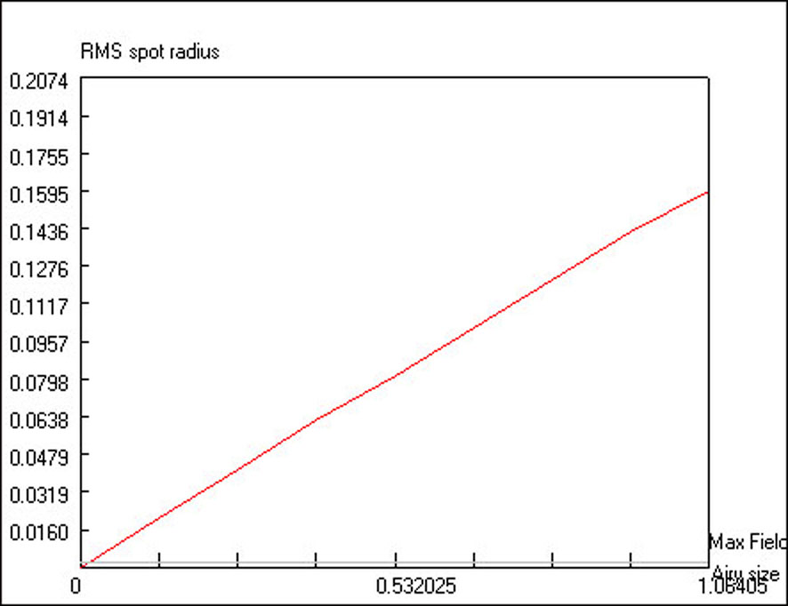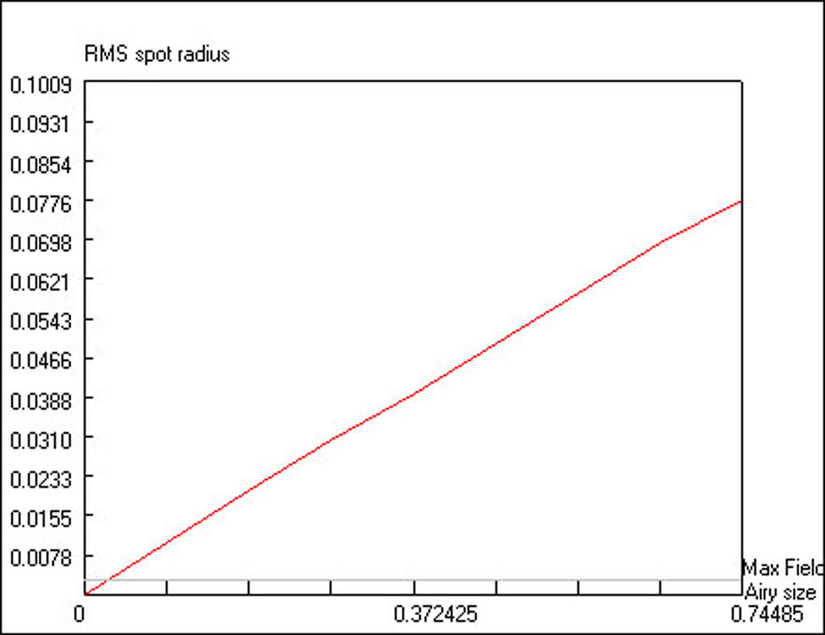

Fig. 9: 0.5m f2.8, 26mm off-axis (52mm field diameter) Fig. 10: 0.5m f4, 26mm off-axis (52mm field diameter)

Fig. 11 shows f8, which has a 38.8 micron spot diameter at the edge of the field. Even at this slower f-ratio it would only be diffraction-limited over roughly ¼ of the field. It would benefit from a coma corrector, as long as other real-world errors were not larger.

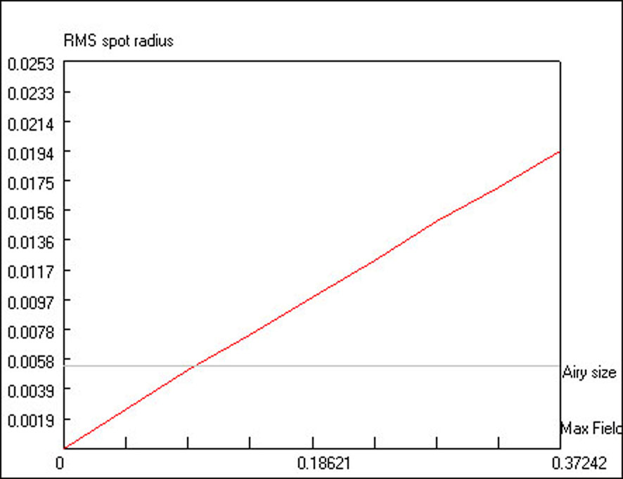

Fig. 11: 0.5m f8, 26mm off-axis (52mm field diameter)

Conclusion
This article has shown that even at the theoretical level, and for fairly small fields, none of the f-ratios and apertures analyzed are diffraction-limited across their respective fields. This is bound by optical physics, not an individual’s skill at finishing a paraboloidal mirror. Understanding this basic provision of optical design & optical physics is essential to gaining a deeper understanding of real-world optics and true installed performance. This can help a person achieve higher installed performance through fact-based knowledge. It can also help a person realize that the atmosphere is not the super villain we’ve all been told. There are a great many factors degrading the installed performance of optical systems. Most of which we have control over.

Thank you,
Shane Santi – Founder & President (610) 360-7874
Dream Aerospace Systems - Nazareth, PA 18064
Buy The Best. Only Cry Once.™

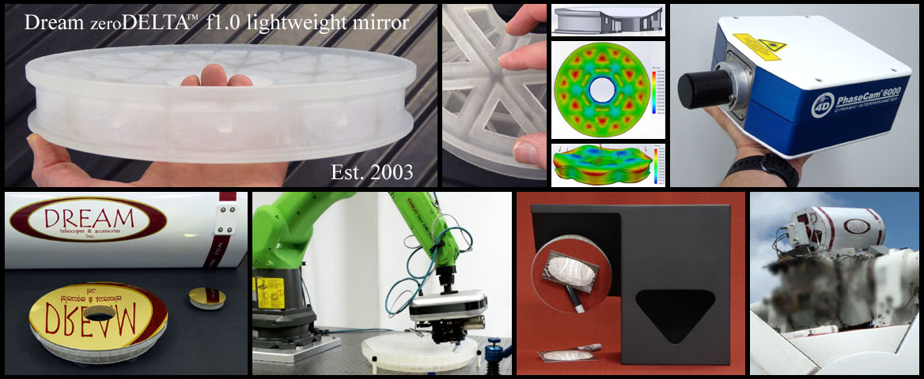

Copyright 2023 Dream Aerospace Systems – Nazareth, PA 18064 – www.dreamscopes.com (610) 360-7874) 360-7874

