Dream Q&A

Shane Santi – President
Dream Aerospace Systems
Copyright 2019 – v7

When and why was Dream formed?
In 2003 Dream's founder, Shane Santi, took aerospace composite technology and optimized it for the extreme thermo and mechanical tolerances of modern, cutting-edge opto-mechanic and electro-optic devices. He recognized that a tailored composite could be made that had all of the attributes desired for optical structures;
- low mass,
- extreme stiffness,
- corrosion resistant,
- low Coefficient of Thermal Expansion (CTE) and
- athermal to the zeroDELTA™engineered, lightweight mirrors they are used with.

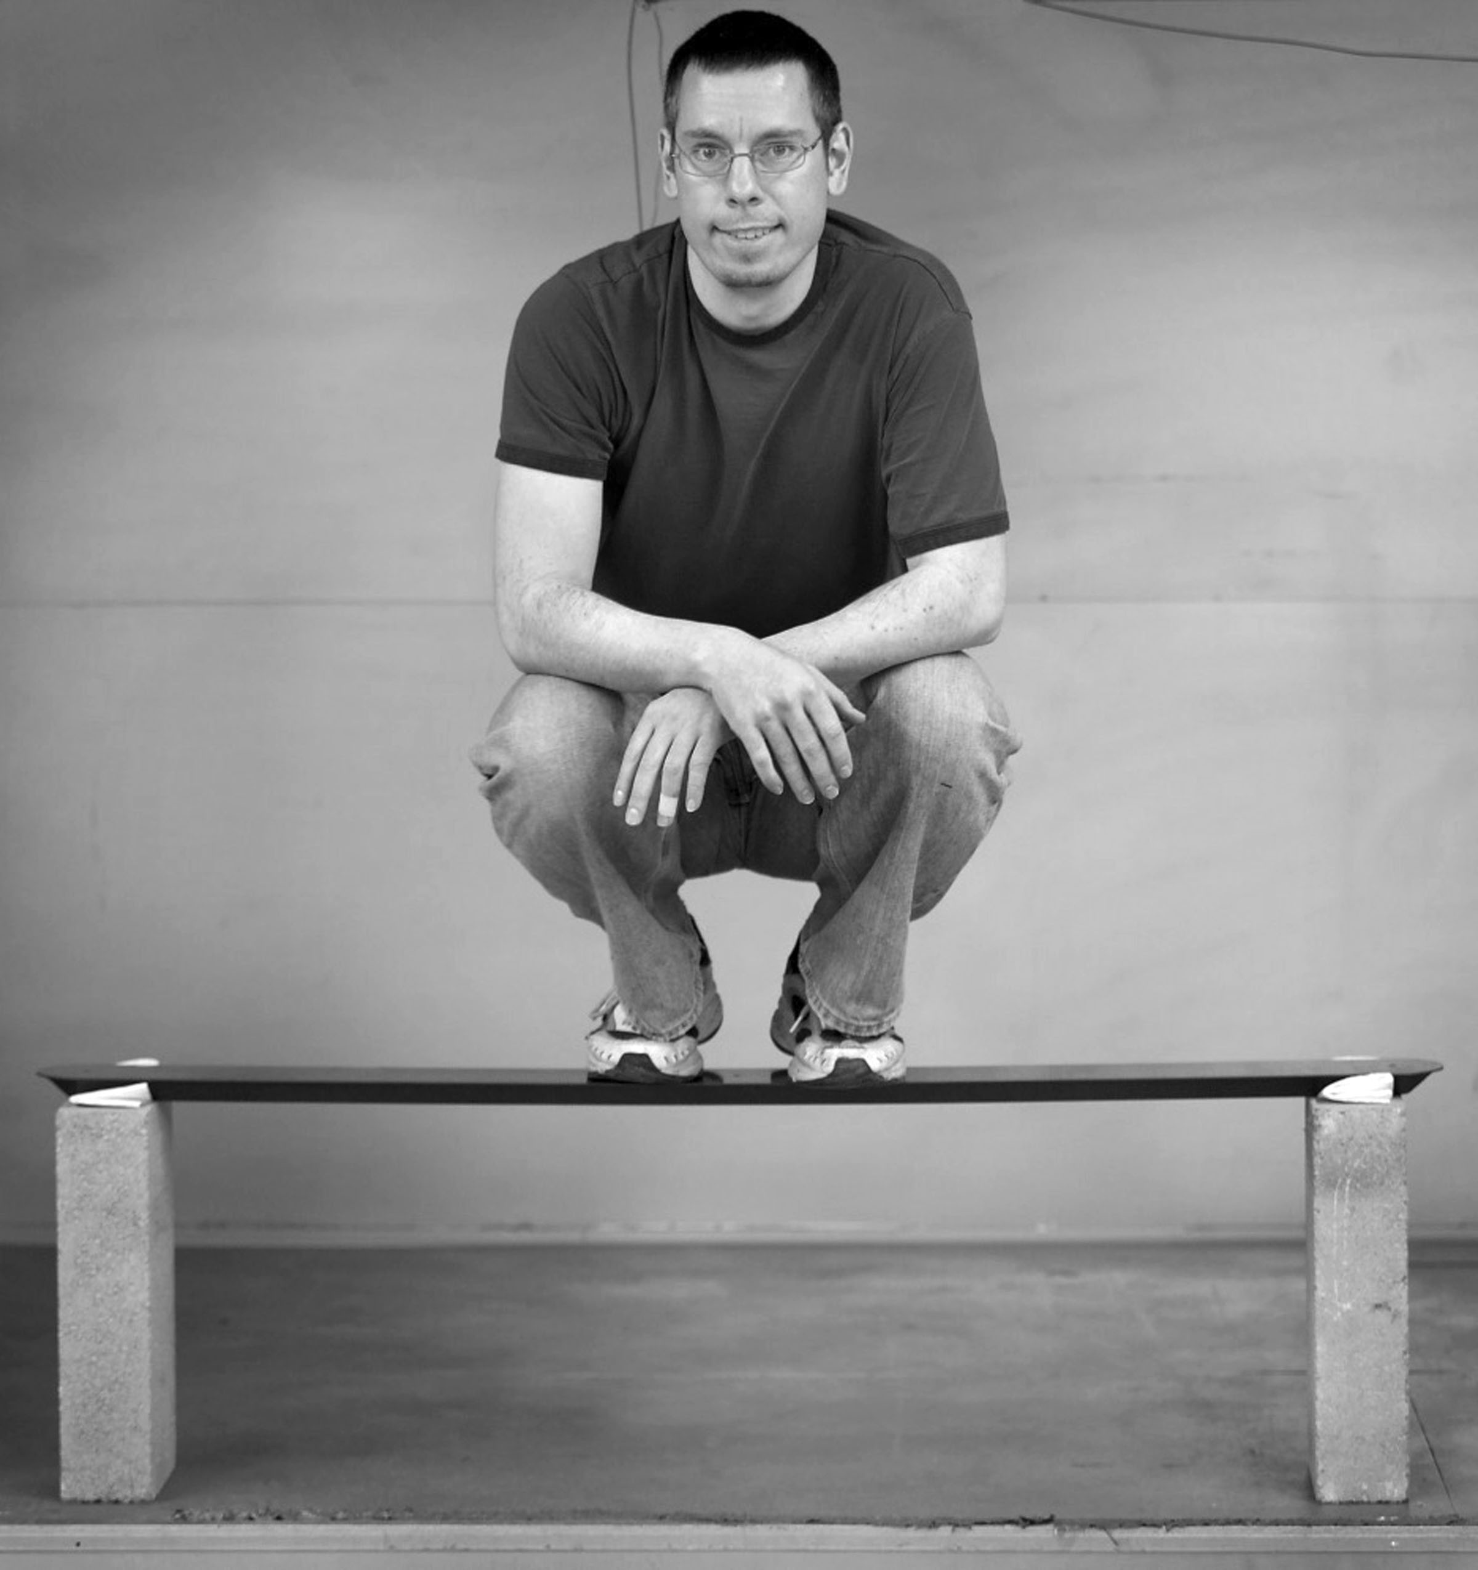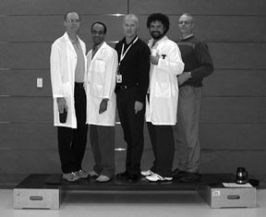
1.85 pound Dream CFSC™ strut 16.0 pound Dream CFSC™ bio-medical board (6’x2’x1.1”)

Standard composite companies had little to no knowledge of optical systems and the extreme stiffness & thermal requirements that come with them, as well as little interest in working with such a demanding customer. Most understand strength well but lack a firm and comprehensive understanding of stiffness; a key driver of the performance of an opto-mechanical systems. There’s no point in finishing optical surfaces to high-performance levels if the structures supporting them are not maintaining that level of quality.

The optimized advanced composite parts need to be designed and fabricated by those who understood just how critical it was to the performance of the instrument, which is why the composite parts have always been designed and fabricated in-house. This has given Dream a direct feedback loop, eliminating the disconnect that occurs between a company and its outside vendors. This has led to countless developments that would not have been possible without internalizing this aspect of the product.

Shane also recognized that lightweight mirrors were another key ingredient of achieving higher performance. He knew that more efficient designs backed by thorough engineering of both polishing displacement (how they act during processing) and gravity displacement (how they act in final use) could allow higher quality and performance, without needing a space budget.

Dream is the only company in the world that has specialized, develops and fabricates its own advanced composite parts and assemblies specifically for the extreme performance sectors of the optical market. Dream has extensive optical - design, engineering and finishing expertise, including everything surrounding lightweight mirrors.

From the beginning the goal was also to offer these more extreme composites in combination with lightweight mirrors. When properly designed and utilized the two technologies are complimentary. Due to the level of optimization Dream’s products are both enabling and disruptive technologies, producing the ultimate in thermal and mechanical performance for modern optical systems, within industry leading SWaP-C.
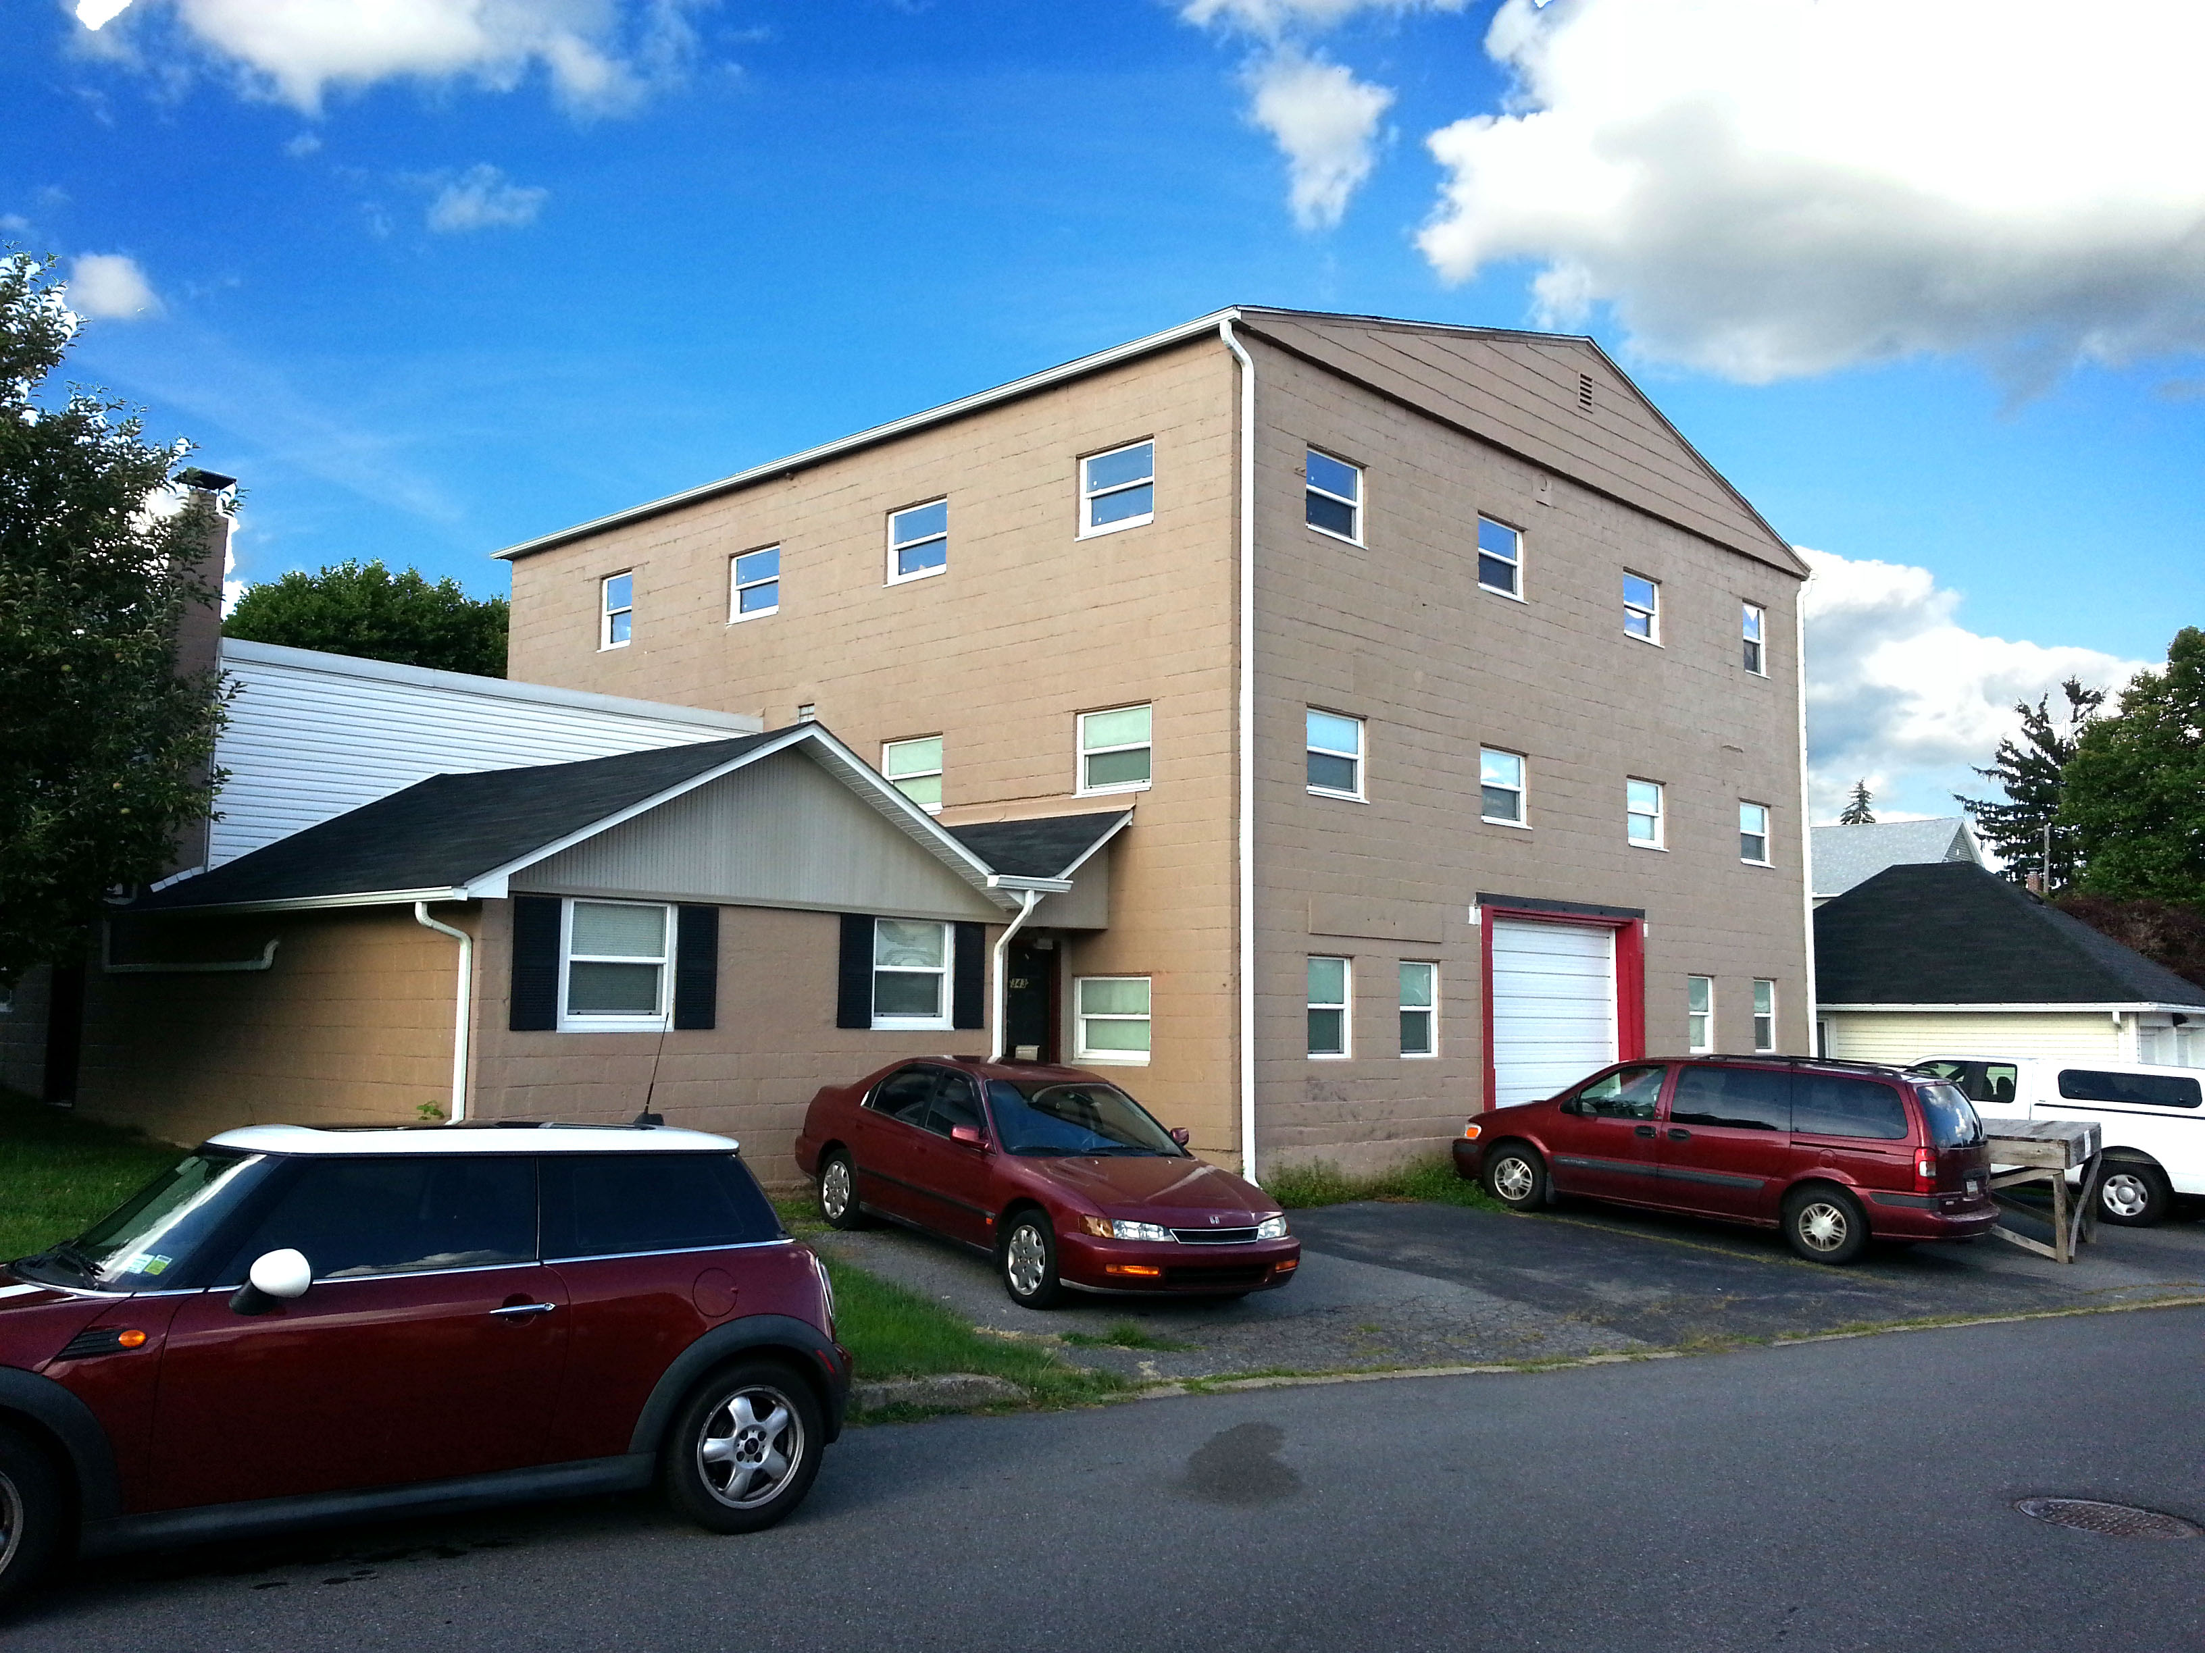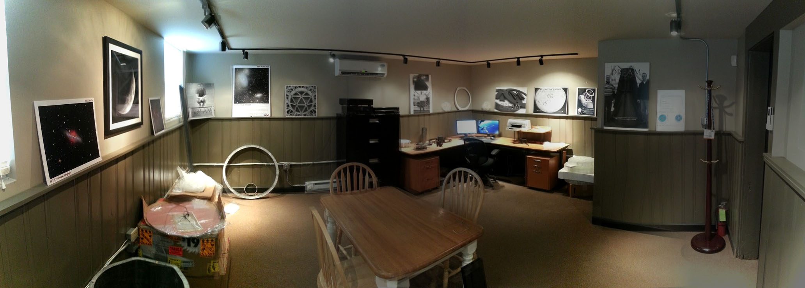
Fig. 1: Dream’s 7000 square foot facility. Fig. 2: Dream’s office and multi-station CAD center.

Dream has grown from its first 1100 square foot facility in 2003 to our third and current space, which is a three-story, 7000 square foot facility in Nazareth, PA. The current facility has all of the amenities the first two lacked, especially related to processing mirrors. The 3-story building allows Dream to vertically test mirrors, as well as provide space for our equipment, like our largest CNC that can machine (5'x10') and largest composite oven (6’x12’x6’).

What does advanced composites mean?
A composite is the combination of two or more different materials. Plywood and concrete are each examples. Advanced composites is a narrower term used to describe structures or parts that have one or more of the four main reinforcements, along with a resin (adhesive);
- S glass,
- Kevlar,
- carbon fiber and
- ceramics.

S glass is a variation of traditional fiberglass (E-glass). S-glass is stronger than fiberglass but still not nearly as strong and stiff as the remaining types. Kevlar has excellent abrasion resistance, low CTE and is the only type that acts like a metal; bends like metals before failing. Carbon fiber (CF) is stiffer than the others and makes an ideal raw material for use with opto-mechanical instruments. Ceramics are generally used for applications that require the part to be near or directly touching very high temperatures; up to 1650°C. Dream uses numerous types of specific carbon fibers. There is no fiberglass in our carbon fiber telescopes and our structural weight of the structure is 95% carbon fiber. Make sure your “carbon fiber” instrument is actually living up to its name because most use 5-10% carbon fiber, with the majority being low-cost, high CTE aluminum.

Why is CTE a critical aspect of an opto-mechanical system?
Steel bridges have expansion joints that allow them to expand and contract without tearing the bridge apart. In opto-mechanical systems this expansion/contraction can easily distort the mirror and/or lens. The scale between these two examples is critical. It’s perfectly fine if the steel bridge moves by inches or even feet, for long spans. But mirror mounts need to maintain the surface of the mirror, as it moves during real-world use, to a fraction of a wavelength of light. This is an extreme mechanical & thermal requirement that deals with stiffness, not strength, and the difference in CTE between the mirror (or lens) mount and the optic itself.
If we only had to make a mirror mount that performed well in one orientation (no angle change of the mirror) and at one specific temperature (+/-0.1°C), a wide range of simpler designs and materials could be used. But as soon as the temperature and mirror angle(s) change, the challenges become exponentially more difficult and complex.

Dream has always used its engineered carbon fiber, especially carbon fiber skinned sandwich core, extensively in the structures it produces. Dream consistently averages 95% carbon fiber and only 5% metals for the weight of the structures (no optics). At least 4% of the metal used is stainless steel. Dream’s carbon fiber is used for everything from mirror mounts, backplates, main structure(s), flange/mounting platforms and more.

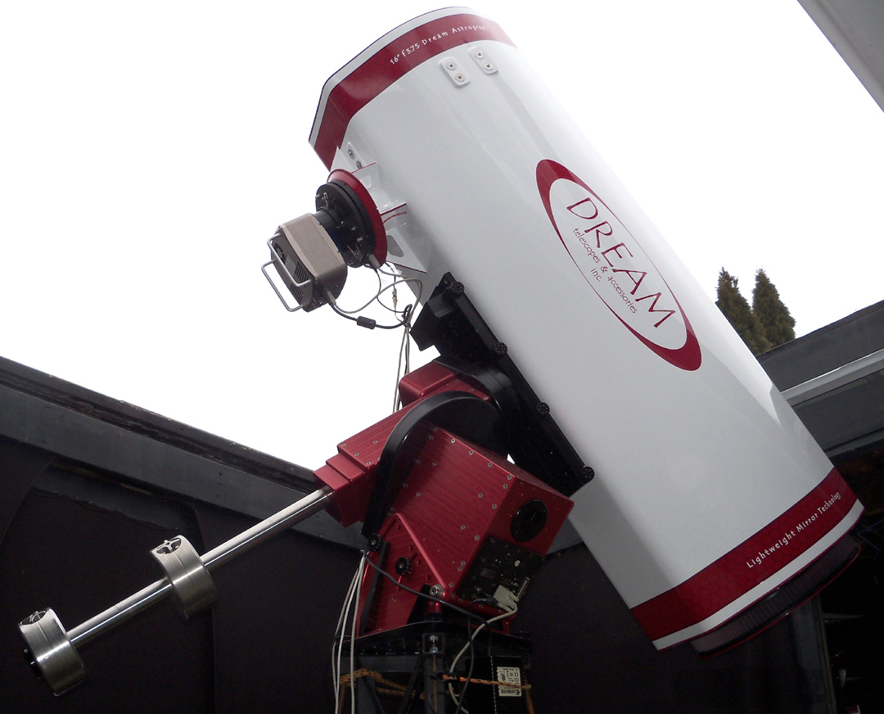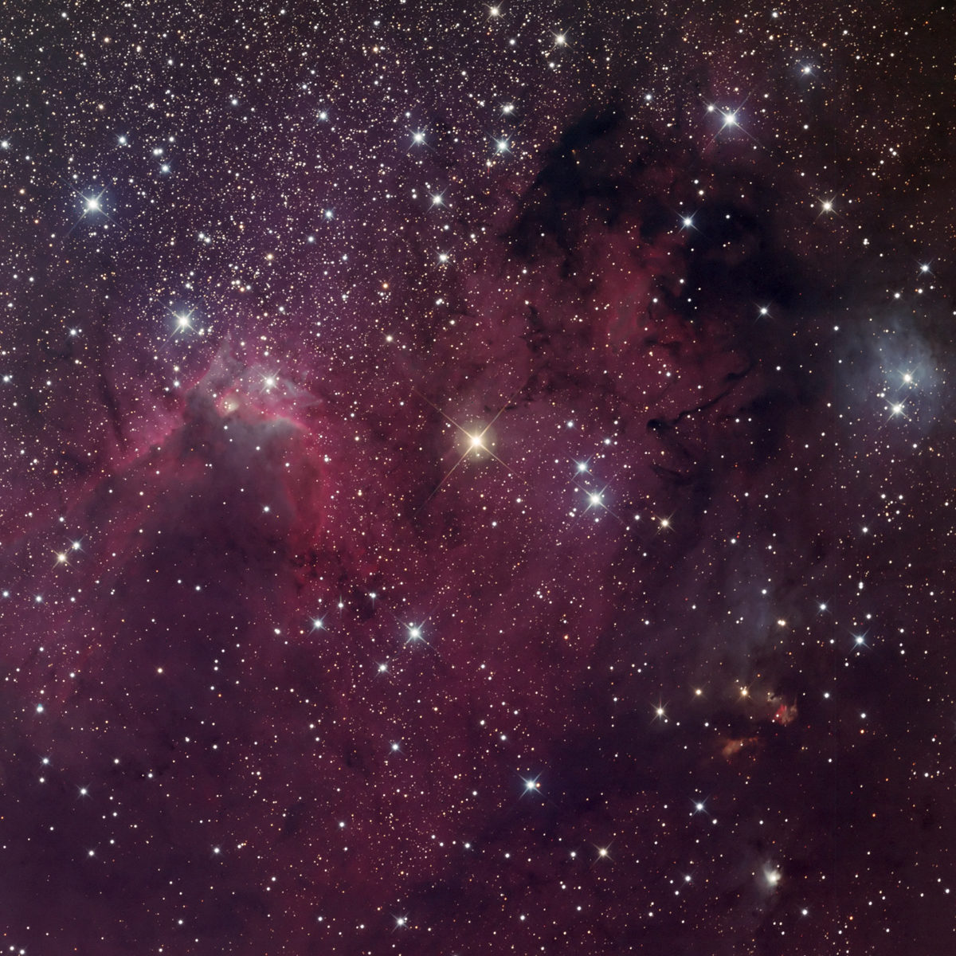
Fig. 3: 16” f3.75 Dream Astrograph telescope. Fig. 4:Customer image of Sh2-155, The Cave Nebula.

Below are two benefits of low CTE for an opto-mechanical system:
- Reduction or elimination of instrument focus shifts during temperature changes.
- Mirror mount performance is greatly optimized & stabilized.

As temperature changes, both the mirror and the low CTE mirror mount change at the same or very close to the same rate. This has enormous advantages for opto-mechanical systems:
- Simplifies the mirror mount design, eliminating the need for flexures and other complex methods that properly support but also allow for the mismatch in CTE between mirror and mirror mount.
- Greatly reduces the likelihood of the mirror’s figure being moderately to grossly distorted, due to the mirror mount expanding/contracting around it.
- Allows tighter optical tolerances to be maintained in the mirror and/or lens.
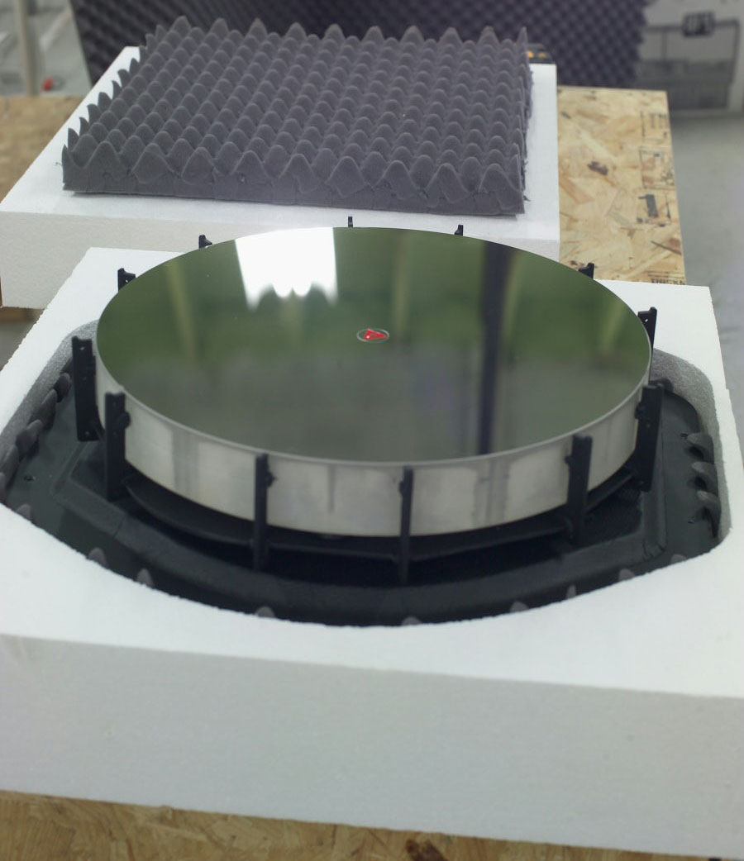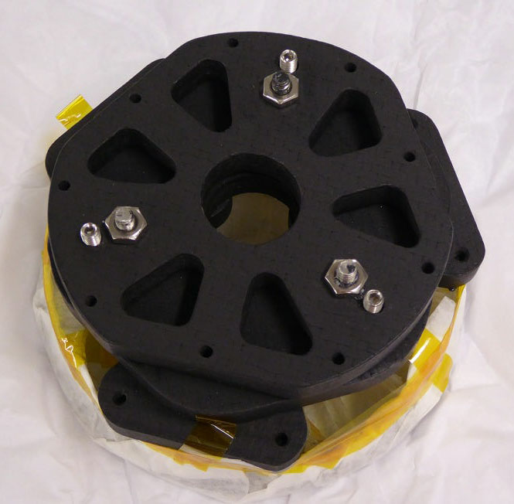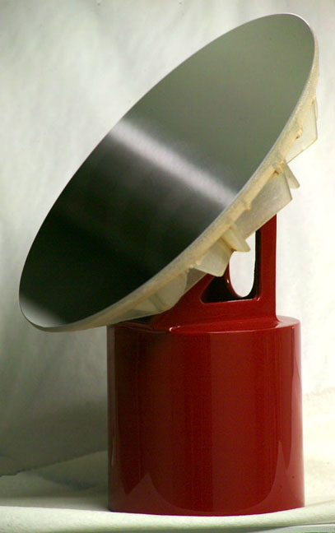
Fig. 5: 16” Dream mirror and CF support. Fig. 6: CF support & coated M2 (wrapped). Fig. 7: 6” ellipse & CF support.
Dream’s engineered and fabricated carbon fiber is roughly 20 times closer in CTE to our mirrors than inexpensive aluminum. This performance has been verified both by direct CTE tests of Dream’s carbon fiber and through nearly 15 years of use in fast, highly sensitive opto-mechanical systems;

One telescope Dream has more experience with than any other shows off-axis aberrations starting just +/-8µ from optimal focus. Yet the telescope can stay within this small window all-sky (EQ mounted, not the less demanding alt/az) and it can maintain this performance over at least a 20°F ambient temperature change. http://dreamscopes.com/pages/2011/16inDAtube_u7_02.htm

Isn’t this level of CTE matching overkill, considering telescopes have changed little in roughly 350 years (mirror-based) and carbon fiber has only been around since the 1950’s?
We have been testing Dream’s full telescopes, not just the individual components, since the beginning of the company. This is done outside, under astronomical conditions and across the sky; different telescope angles. This real-world testing is key. Testing a mirror without its final support, in one position and at one temperature is a far less demanding test and is not a test of the full system.

It has never been difficult to see both thermal and mechanical issues, even from our less than ideal location; 75 miles north of Philadelphia and 75 miles west of NYC, at roughly 490’ elevation. The first few years of Dream were extremely informative and educational because of this type of testing. Finding, then fixing the issues seen and re-testing was invaluable then and remains a part of what we do.

In 2017 one of our 16” Cassegrain telescopes achieved sub-arc-second raw image resolution (no processing at all) from the center of town. Traditionalists want you to keep buying what they’ve always sold. It is ridiculous to believe that the mousetrap cannot be improved upon after 100, 200 or 350 years.
http://dreamscopes.com/images%26graphics/2017/DreamArticle_UsingMoonToQuantifyResolutionAchieved_v2_060417.doc

Those in precision optical metrology know that mirrors are anything but solid (stiff) and are therefore quite easy to distort. Remember, we are down in the fractions of a wavelength of light for the tolerance of that optical surface. It doesn’t take much force to bend the optical surface at this scale. The larger the mirror, the easier it is to bend, even when it is at a 6:1 aspect ratio.
http://dreamscopes.com/images%26graphics/2017/DreamArticle_AspectRatio%26Stiffness_v4_043017.doc

In the real-world it is quite challenging to support a mirror without distorting it by small to moderate amounts, even when using Dream’s CF, let alone using much higher CTE aluminum. This is true at Near InfraRed (NIR) wavelengths, then even more so as you go down toward UV wavelengths. Because of this, mirror mounts play a very large role in the quality of the mirror they hold and therefore the quality of the finished instrument. If you can’t detect “any” errors, chances are high that the test method used is too low in resolution.

Is all carbon fiber the same?
Like metals CF is offered in a myriad of variations for the raw fiber; from numerous types of PAN-based to numerous types of pitch-based. These are typically broken down into high strength to high stiffness. These raw individual, very small, continuous fibers are then combined with thousands of other individual fibers to form what are called tows. Tows are akin to thread in the apparel industry. Tows typically have 3k, 6k, 12k and 24k individual fibers within each tow! Tow is one of the driving factors for the “weight” (thickness) of the (dry – no resin) CF. The resin system being the other driver.

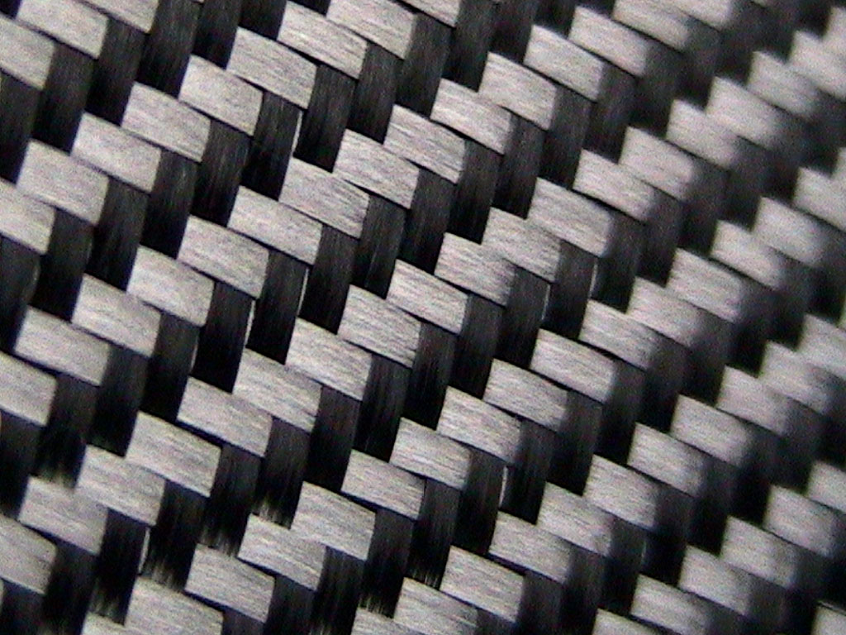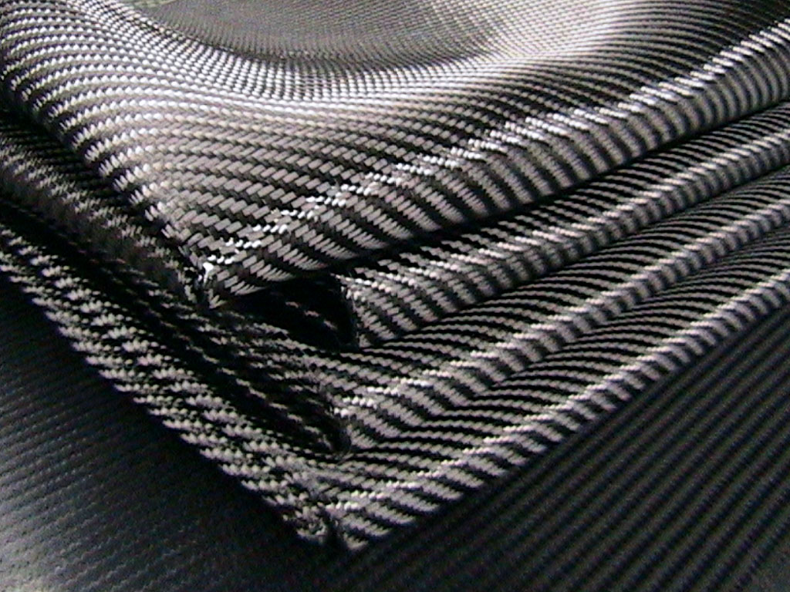
Fig. 8: Close up of woven CF fabric. Fig. 9: Cut and folded pieces of CF fabric.

Tows can then be woven into fabrics or used to create unidirectionals, which have tows running in one direction only. There are literally tens of thousands of different variations and combinations. This is one of many design and fabrication freedoms that allow Dream to tailor the layup to fit exactly what we are trying to achieve. But it is also why press quotes saying carbon fiber is X stronger or stiffer is akin to saying “metal” is this or that. What metal? How was it used? What was the shape? Was it welded or bolted together? Etc., etc.

How important is the choice of resin (adhesive)?
There are tens of thousands of types of resins. Room temperature epoxies were tested in January of 2003. It was quickly realized that these easy to use and inexpensive epoxies had limitations due to their low glass transition temperatures (Tg). Excess heat in advanced composites can facilitate a breakdown of the laminate, especially with room temperature-cured resins. The separate layers of CF will start to delaminate from each other over time if a temperature threshold is exceeded, which takes less than one might think. This can make the “carbon fiber” elastic, which is the opposite of stiffness.

A test was conducted to determine what temperature a black-surfaced material would go to in the Sun. With an outside temperature of only 70°F on a blue sky day at noon, the material exceeded 160°F. This proved that using a high temperature epoxy and baking the parts was a must for higher performance. It raises the Tg, as well as other performance aspects; high-temperature resins often have higher mechanical performance as well.

It was at this time that an optimal high temperature and high performance epoxy was found. We continue to use this epoxy today due to its unique mechanical and thermal properties, as they relate to toughness, stiffness and CTE, as well as how those relate to the Dream zeroDELTA™ engineered lightweight mirrors.

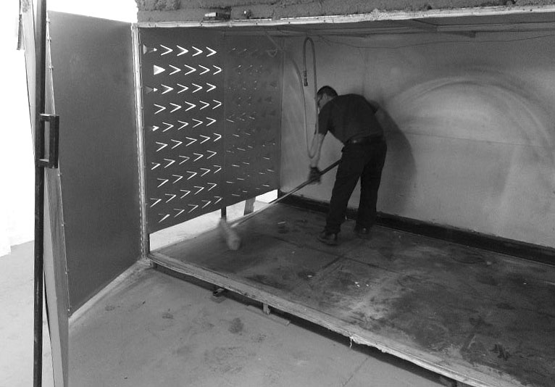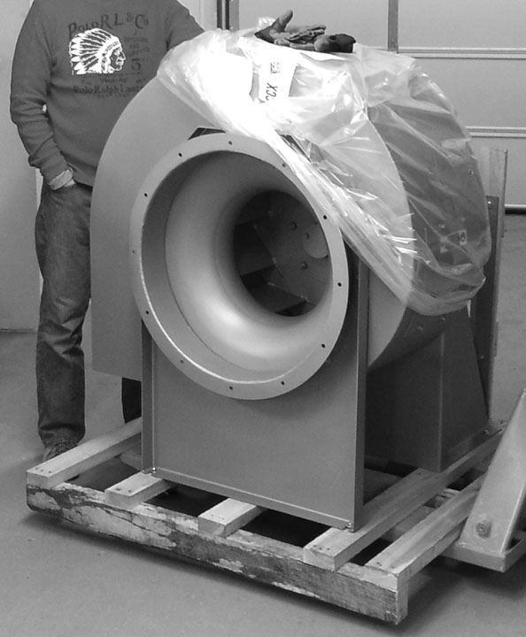
Fig. 10: Interior of Dream’s largest composite oven. Fig.11: 700 pound composite oven blower.

After roughly 10 years of use Dream's largest oven was upgraded. It went from 10,000 to 36,000 watts, as well as upgrading the blower to a unit 20x more powerful. The interior is 144" wide, ~75" deep and ~68" tall. These dimensions where chosen so the oven could handle long and/or large structures, for up to 1.5m telescope structures in astronomy. The oven is processor-controlled through a closed loop system and uses forced horizontal air flow, using the 700 pound blower shown above right. The oven can easily maintain a tight temperature tolerance of +/-1°F, which is roughly one magnitude tighter than normal aerospace composite industry ovens.

The vast majority of resin systems, including epoxy, are UV sensitive. The dry CF itself isn’t UV sensitive but the resin is. If the part is left to “show off” the carbon fiber, the clear coat must be applied properly and it must have adequate UV protection within it. Otherwise the CF parts can degrade over time. Because of this risk and the fact that allowing optics to heat up is so detrimental to their use, Dream has chosen to focus on performance and longevity. Our “bling” is in the performance.

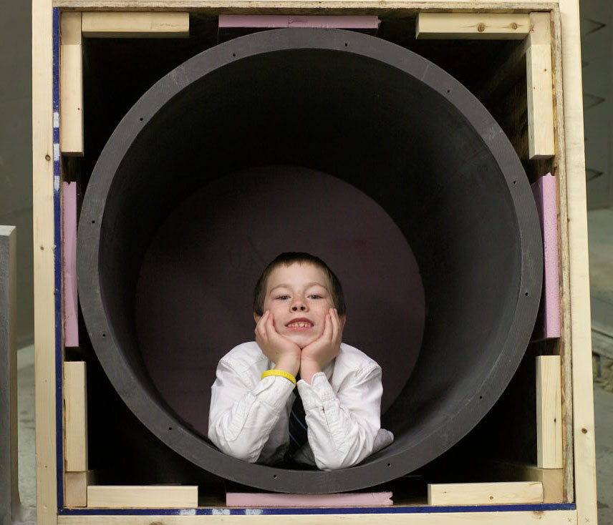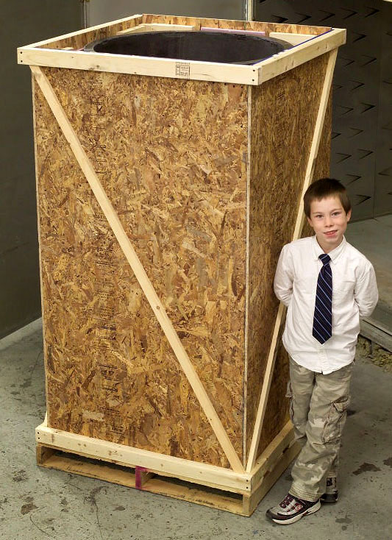
Fig. 12: 34” OD, 1.55” wall thickness, 66.5” long Dream CFSC tube. Fig. 13: Crated tube from Fig. 12.

If the part is carbon fiber, won’t it outperform everything else? After all it’s “Carbon Fiber.”
Above we discussed the extremely wide range of variations that are offered in the raw CF material and in the resin systems. Once you add sandwich core the combinations and therefore performance can vary over a huge range. This is why it was a must to bring the advanced composite work in-house.

One of the final factors in part performance is the exact fabrication method and its consistency. Consistency is both within the bulk of a single part and part-to-part consistency. The high number of variables means that it is vital that CF parts are produced correctly and consistently. Corvettes don’t need this level of performance and consistency out of their carbon fiber bumpers but it is needed for opto-mechanical applications.

“Carbon Fiber” is just a phrase. It tells you nothing about how the parts were designed, fabricated, what resin system was used, whether it was baked, whether the shop understands the ramification to opto-mechanical systems, whether the company understands the vital and key differences between strength and stiffness, etc., etc. Having a “Carbon Fiber” part alone does not mean the part is the ultimate in performance. There are too many variables at play and loosing sight of any one of them will change the part performance.

What is vacuum bagging and how does it benefit the parts?
Before Dream was formed, R&D was conducted using wet lay up without vacuum bagging. The parts were “carbon fiber,” but when loaded they would make cracking sounds. This sound comes from void areas collapsing between the layers of CF. This is why vacuum bagging, or some other form of high force, is so critical to quality CF parts. The difference in consolidation and part performance is enormous.

Vacuum bagging pulls out air at a fairly high force. When done properly this vacuum force compacts the lay up, which forces moisture, trapped air and other unwanted voids out of the part. It also compacts the layers so the fibers are closer to each other. The resin system only acts to hold things together. The bulk of the load-bearing performance of the part is coming from the fibers, not the (heavy) resin.

Vacuum bagging adds roughly one ton per square foot of force. That’s one ton on an area slightly larger than a sheet of paper. A part with 10 square feet of surface area will have 10 tons of force across the part’s surface. Other fabrication techniques, like Saran-wrapping, are far simpler, faster and less expensive, but they do not apply force as evenly and they can use 20-100 times less force. That’s akin to a large leak in the vacuum bag or shutting off the vacuum pump entirely. Uneven application of force will create resin rich and larger void areas, as well as thickness variations, which affect the CTE, stiffness and strength of the part.

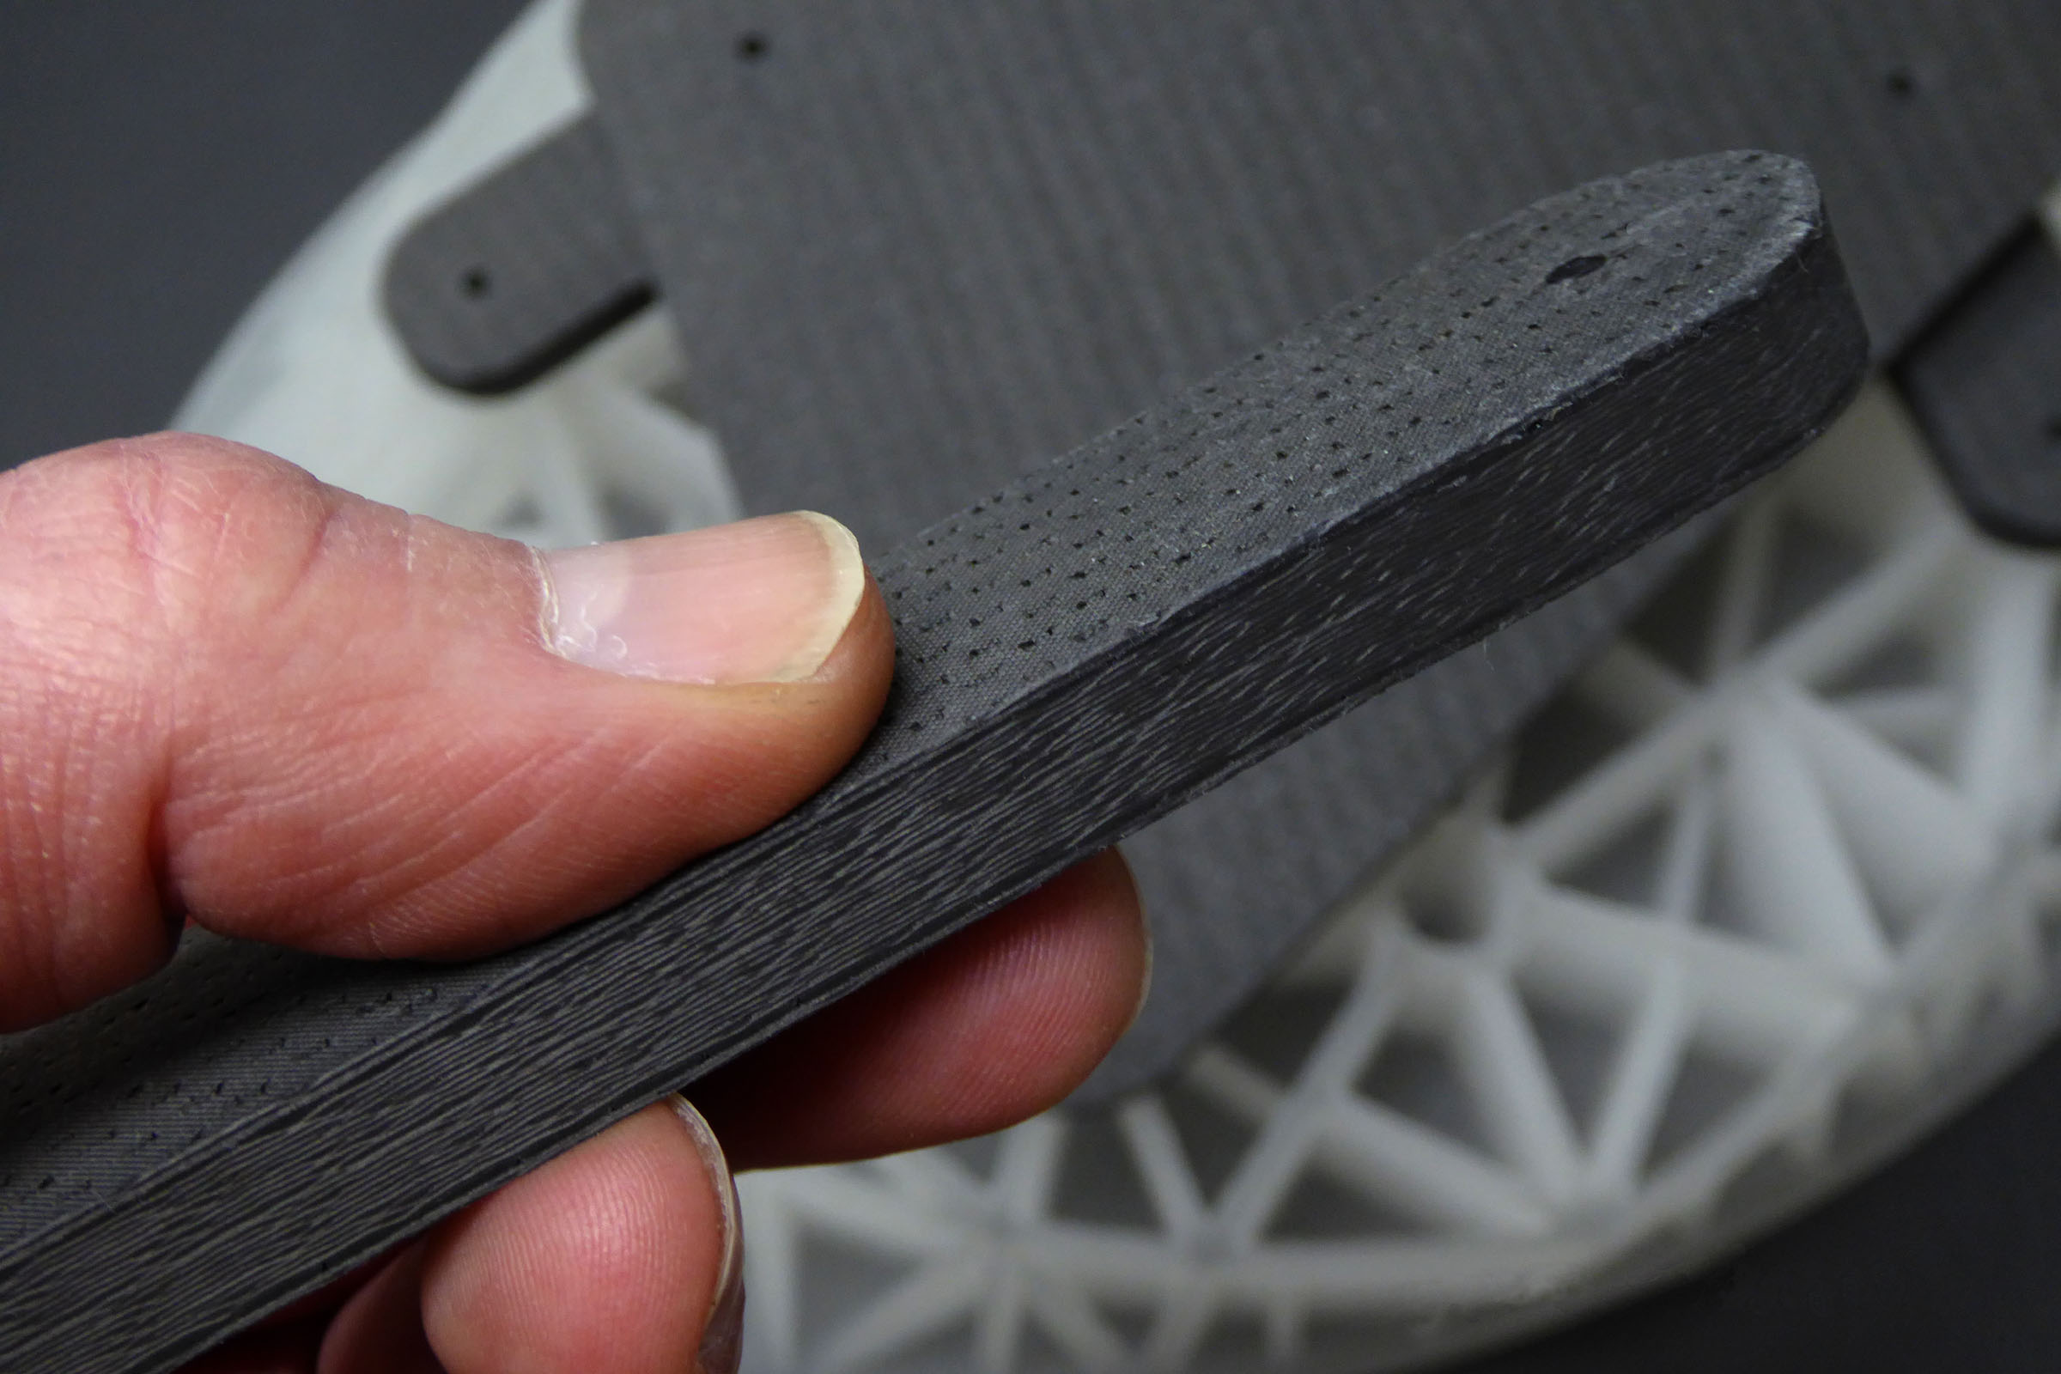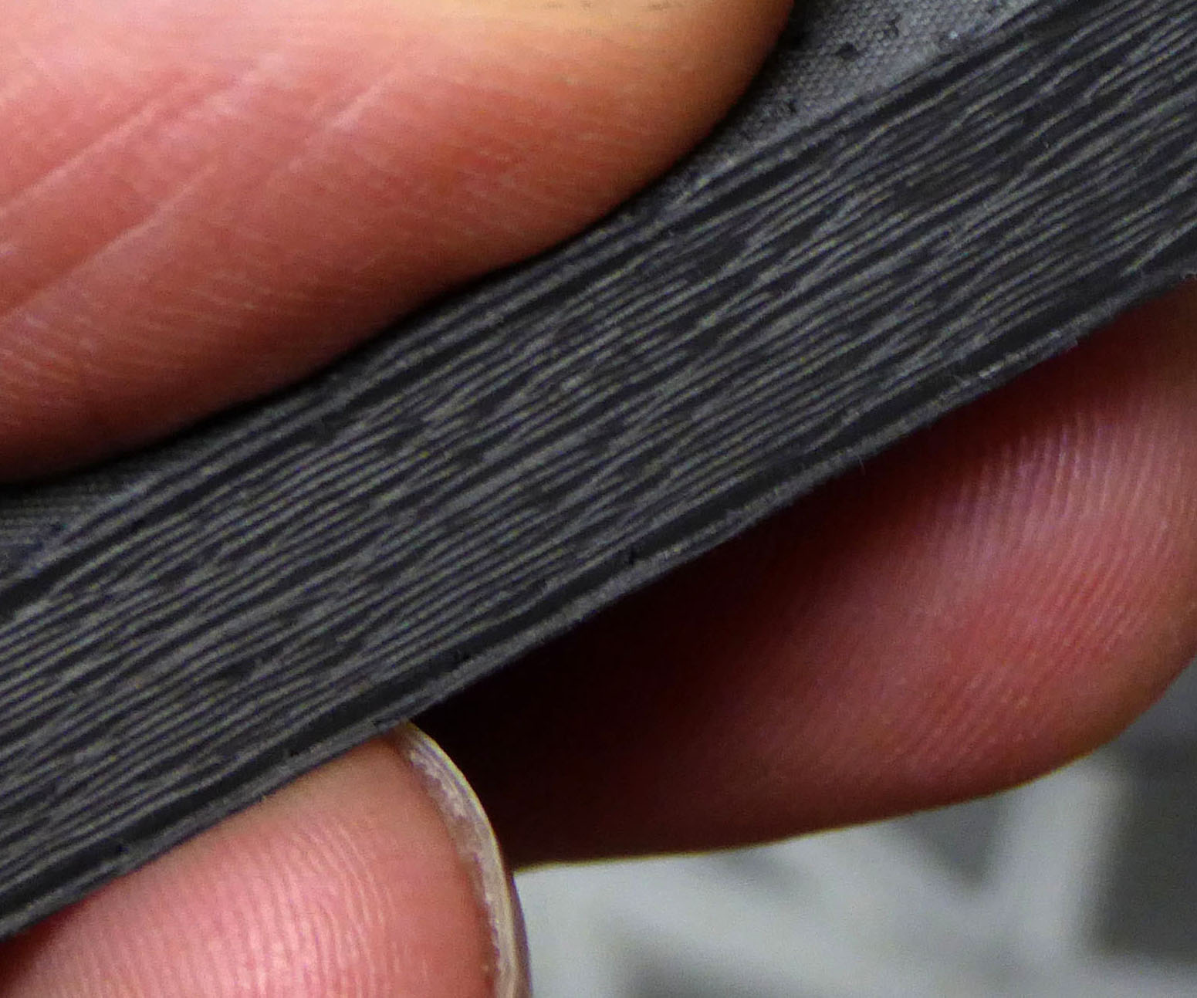
Fig. 14: Dream’s CF and large, lightweight elliptical mirror. Fig. 15: Close up view of Dream’s solid laminate CF.

Isn’t carbon fiber brittle and therefore fragile?
Yes, when you run it into a wall at 200mph, it will shatter… As stated above part performance is a combination of a high number of variables. Get lax with a few of the variables and the part will neither have the performance, nor the consistency.

Strength allows a bridge to take high loads, while bending and therefore absorbing traffic, vibrations and wind loading. Strength is rarely a large driver in opto-mechanical systems because it is the optics themselves, not the structures, that are typically the most fragile portion of the system and therefore the first part that will break.

A bridge needs strength and a lack of stiffness. High stiffness in bridges, building and ships is the opposite of what they need. Just as high strength is rarely what we need in opto-mechanical structures. It is stiffness, low mass and low CTE that are the driving and desirable factors for optics.

However, Dream’s high performance products can take extreme punishment too, illustrating Dream’s level of expertise with composites. Performance lies in the details. The link below shows the how rugged Dream’s Carbon Fiber skinned Sandwich Core (CFSC™) composites are, with a skin that is just over 20 thou thick: http://dreamscopes.com/impact.htm

What is sandwich core?
There are numerous main types of sandwich core, then dozens to hundreds of variations within each. The basis of sandwich core is the comparison of a solid plate of steel versus an “I” beam of the same weight. The “I” beam is a much more efficient shape than the solid plate. The “I” beam is both stiffer and stronger than the same mass steel plate.

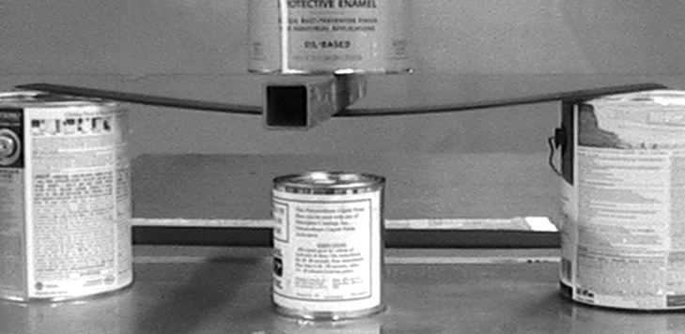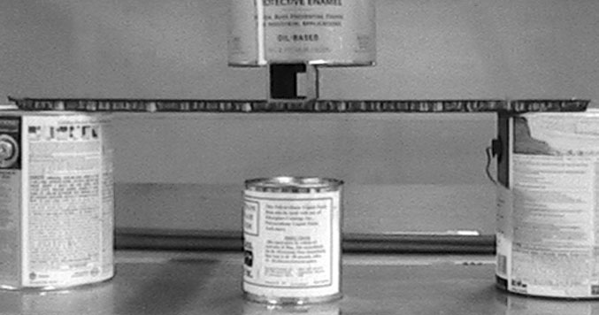
Fig. 16: Early internal testing; solid laminate CF, 14 layers. Fig. 17: CFSC™, 2 CF layers per skin, 0.5” sandwich core.

Above are vintage photos of some of the first tests Dream conducted comparing the stiffness between solid laminate CF and Dream’s CFSC™. Both samples were 4" x 25", using the same CF fabric, same high temperature epoxy, vacuum bagged and baked using the same oven schedule; ramp rates, set point, etc. Both are loaded in the photos with 24.2 pounds during this 3-point bend test. The sandwich core sample above is not only far stiffer but it is also 35% lighter than the solid laminate sample above. Although Dream now owns multiple non-contact distance sensors that can measure up to 3mm of deflection, at a resolution of 20 nanometers, these early and simple tests show the benefits of Dream’s CFSC™ versus solid laminate CF.

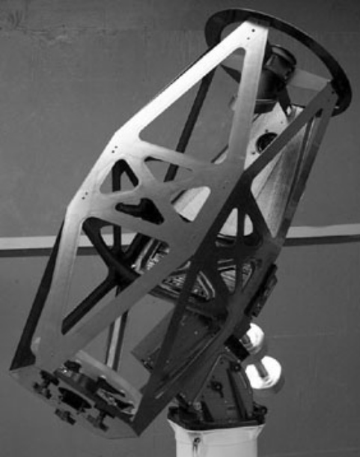
Fig. 18: CFSC™ strut example. Fig. 19: CFSC™ truss structure.

Sandwich core is used between two skins of CF. The CF skins can have any number of layers of CF within each skin. Those CF skins act as the flanges of the “I” beam, while the sandwich core acts as the web; the vertical portion of the “I.” Pound for pound Dream’s CFSC™ is substantially stiffer and stronger than solid laminate; a composite without sandwich core. Dream has always specialized in the use of sandwich core because it is the ultimate in performance. The gains in stiffness, as illustrated by the 1.85 pound strut below, are truly remarkable.

Dream’s CFSC™ strut to the left is 55.7" wide, 4.0" deep and 1.1" in height. It is shown under 195 pounds of "live" load in a conventional 3-point bend arrangement. Dream has been achieving this type of stiffness since first starting to use sandwich core back in 2003. We know from ~15 years of experience that if you take away any one of the key requirements to designing and fabricating quality CF/CFSC™ parts, the performance will be noticeably impacted in an opto-mechanical system. If you can’t notice it, then your system has other errors that are even larger.

Why does Dream seem obsessed with weight?
It isn’t mass alone that is the problem but the thermal and mechanical baggage that come with it. An attempt is made to use composites instead of metals, for both faster equalization of all components and for stiffness gains.

Everyone knows what general mirror seeing is but every part of the telescope can contribute to the seeing affect of the total instrument. Burying a full-thickness solid primary mirror at the bottom of a thick-walled steel telescope tube with no ventilation is truly a horrible combination. In comparison, an open-truss telescope structure no longer exacerbates the problem of mirror seeing, although it doesn’t make it go away either. At least it is no longer acting like an insulator, the way a non-ventilated, solid tube structure does. Although it does so at the expense of completely exposing the optics to dirty air.

Stiffness is the foundation of any opto-mechanical system. The system needs to maintain its optical alignment as it moves. The more the optical components move in relation to each other, the more performance is degraded. The use of Dream’s CFSC™ allows the replacement of a metal part with something that is both substantially lighter and substantially stiffer, while also closely matching the CTE of the optic(s) - athermal.

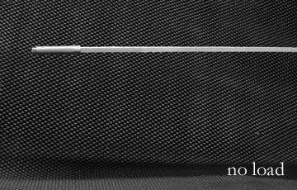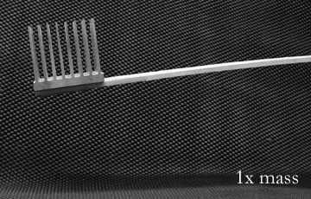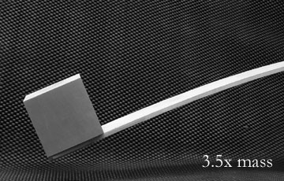
Fig. 20: Support with no load. Fig. 21:Support now with 1x load. Fig. 22: Support with 3.5x load.

If a lighter primary mirror is used, without changing the mirror mount, then the latter will bend less and the former will maintain a tighter optical alignment tolerance. If both the mirror and the mirror mount are lighter, then they are bending the backplate less. This basic concept is true for the secondary mirror and its mirror mount as well. If all components are lighter, stiffer and more thermally stable, the main telescope structure will bend less and provide higher optical performance. This domino effect adds up to noticeable improvements, including in the performance of the telescope mounting; max slew speeds can increase, pointing, tracking and model consistency are all improved.

Optimizing the performance of both the thermal aspects and the stiffness of the system can allow the utmost in performance and the highest throughput, which benefits the vast majority of applications that use telescopes/opto-mechanical devices. Even from less than ideal locations these improvements can be detected. These improvements cannot be detected unless something is changed in the 350 year-old technologies.

Won’t making the instrument light make it more prone to vibration issues?
Even with our core technologies of lightweight mirrors and lightweight structures the full instrument is not going to blow away. It’s not that light. We have over a decade of customer performance to prove this. The other way to answer this question is to ask 1m+ telescope managers if they have wind buffeting of the secondary mirrors. Even when copious amounts of thick steel are used, there is still vibrations in those instruments. In meter-class Dream’s technologies are even lighter; up to 4-10 times lower in mass.

Throwing mass at the problem does not help and is a traditionalist “solution” that keeps performance firmly in the 18th and 19th century. In fact mass will almost always leave the instrument with greater thermal problems. This trades a psychological fear for a century’s old real and substantial one.
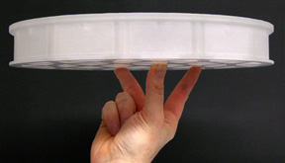
One of Dream’s zeroDELTA™ engineered lightweight mirrors.

In mechanics strength and stiffness are two separate properties of a material, not one. We spend most of our lives surrounded by products that require strength, not stiffness. The necessity for high stiffness is fairly unique to opto-mechanical structures, especially the scale. Even if a system can achieve the required stiffness, excess mass creates thermal problems that cannot be overcome by stiffness. It is bad science to believe the use of a solid zero-expansion mirror material eliminates all thermal problems. What is the CTE of the mirror mount relative to the mirror material? Does the mirror mount use flexures and was the mirror mounted properly in those flexures? Keep in mind that flexures, on the surface, seem to solve all issues, but how they can themselves also distort the optical surface, is quite complex. What does CTE do for thermal mass of the optic?

What is CME and how does it affect different parts and different applications?
CME is the Coefficient of Moisture Expansion of a part, whether that’s Nylon, carbon fiber matrix (carbon fiber and resin system) or any other material that changes dimension as the moisture content changes. It’s like CTE except it is moisture in the ambient air surrounding the part, not temperature, which is influencing the dimensional stability of the part. However, there are some key differences and like everything else in optics and high-performance structures, the details matter. Keep in mind that CME is typically not related to drops of moisture but moisture either going into or leaving the interior of materials we might view as solids. This is why a change in moisture content, as it relates to CME, is not rapid.

Carbon fiber by itself will not change dimension as moisture content changes. It is the resin system that holds the fibers together that can be influenced by the moisture content. CME therefore lies in the space between fibers and between layers of carbon fiber. These specific locations are driving CME, not the carbon fiber itself. Because of this CME will have no influence on say the length of a CF or CFSC™ tube when continuous (not cut) fibers are used down the length of that tube or across that part. But if short/chopped strand is used, then CME can be a much larger issue. Dream specializes in the use of continuous fiber and has never used chopped fiber. This was not due to CME but due to the greatly improved strength and stiffness achieved by using continuous fibers.

Because one of the drivers of CME is the space between fibers the resin content of the part matters. If twice as much resin is used, the CME will be larger. If the part is fabricated without vacuum bagging or similar forces, then the void content can be higher as well. Voids (air, moisture, debris, etc.) space the fibers even farther apart and can also increase CME in that direction. As mentioned, direction and location have to be defined when speaking about CME.

There are tens of thousands of different resin systems that can be used with carbon fiber. Each will react differently to moisture and therefore each will affect CME differently. As outlined above knowing the resin type alone is not enough because the fiber to resin ratio, continuous versus chopped fibers and void content can all independently influence the CME.

A thick solid laminate (no sandwich core - Fig. 14, 15 & 16) carbon fiber matrix has to use substantially more layers to achieve the same stiffness as a CFSC™ part (Fig. 17, 18 & 19). CME is in the interlaminar areas so the more layers there are, the greater CME will affect the composite, as outlined above. There are far fewer layers of CF skinning sandwich core, which means CME is well below the CTE, differential CTE and stiffness performance of the composite when Dream’s CFSC™ is used.

Composites, like carbon fiber matrix, used in space are unique in that in their first month up in the vacuum of space they will dry out, if they weren't dry at launch. But it takes a month for this to happen fully, not one night. If the optical system did not include any focus mechanism, then a high moisture content at launch and high CME in the directions that actually affect the optical system could make the optical system shift focus over the first month in space. In some specific situations this could fail the mission. However, if the assembly was dried prior to launch and/or the system included a focusing mechanism, then the carbon fiber structures will not shift focus or can be compensated for.

After one month in space CME becomes a non-issue, as it won’t change the structure any further. Typically space engineers care about three main topics; weight, power consumption and failure modes. Adding a focusing mechanism might be a requirement for the mission due to different distances to the objects being imaged and/or the affect of a filter change, which can cause a focus shift.

For space systems that do not require a focus mechanism, the use of lighter mirrors and lighter mirror mounts means the focusing system is also lighter. This can end up being the same mass or in some cases even lighter than the original design, eliminating the drawback of weight in adding a focusing mechanism. After one month the spacecraft has equalized and CME will no longer be an issue. This means focus is set and powered focus is no longer needed, eliminating the power consumption of that mechanism.

Even during the month after insertion in orbit, the change in moisture will not require constant focus adjustments. Power consumption is therefore quite small, both because it is not used that often and is only required for the first three to four weeks after orbital insertion. If the craft’s lifespan is two years, one month of focus use means failure risk has been reduced 24 fold.

Certain optical designs and optical elements of space instruments can have extremely tight optical spacing requirement in order to operate at optimal levels. Determining whether CME affects these is specific to each instrument, as well as what type of carbon fiber structures were used, in so many ways. Focusing on CME alone is not enough information to know whether it will or will not cause problems to a given system.

An easy way to deal with space applications is to bake the moisture out of the parts. Even if the payload is exposed to moisture for a day or two prior to being put in orbit, the moisture does not rush in within hours and "fill up" the composite. It takes quite a bit of time. However, a second phase of baking can be controlling the environment the craft is in after the bake and prior to launch.

Ground-based applications see humidity changes that are not only dynamic compared to space but are on much, much shorter time scales. This means CME is not the same scale of issue as it might be in space. CTE and stiffness for ground and airborne is typically the driver, not CME. CME is typically so far below the noise floor that it is irrelevant.

Determining how CME affects the composite for ground and airborne is complex and, depending on all of the specific variables, may never be able to be quantified in actual use. It can even be difficult to quantify in a precision-controlled lab. Stiffness tops the list of performance drivers in opto-mechanical systems, then CTE, then countless thermal issues, like mirror seeing, enclosure seeing (including heat sources inside the enclosure), ground affect, etc.

Dream has produced solid laminate CF and CFSC™ in-house since day one. Dream has used vacuum bagging and baked our parts to properly cure them since day one. As of 2019 we have 16 years of experience designing, fabricating, using & testing our composites and our instruments.

We have 15 years of testing our 400mm f3.75 systems under real-world conditions. This instrument uses a CFSC™ tube that is nearly 1.5m long and 0.5m in diameter. The optical system is sensitive to focus shifts of +/-8µm, yet in 15 years we have never been able to quantify a focus shift due to temperature change. The highest ambient temperature delta we've ever tested an individual instrument through is 20°F, over the course of five nights. During those five nights we never touched focus and it never showed the typical signs of it going out of focus; off-axis aberrations. We've tested numerous units of this design (consistency and 15 years of heritage), in nighttime temperatures ranging from 16°F to 85°F, with humidity ranging from 20% to 100%. Even on this highly sensitive system focus does not shift when humidity goes from say 20% to 60%. Once you understand composites, moisture and the time scales, the answer to why it wouldn't affect it becomes clear.

Dream tests the instruments at different compound angles as well. Again, for this size and design telescope, they hold focus; all-sky. The vast majority of 400mm telescopes on the market will show focus shifts relative to instrument angle so our stiffness is far more important than even CTE, let alone the inconsequential CME factor.

CME might matter for ground and/or airborne applications that are using composite parts laid up with higher resin content levels, poor resin systems, poor consistency and/or parts that aren’t vacuum bagged. All of these can influence the performance and characteristics of the system. The benefits of vacuum bagging are;
- carbon fibers are closer together, since that is where the performance is coming from, not the resin,
- reduces voids, whether this is air and/or moisture,
- forces across the part are more even than a press,
- higher fiber content,
- better fiber wet out,
- better fit to the mold and
- higher quality parts.

Copyright Dream Aerospace Systems - www.dreamscopes.com Nazareth, PA, USA (610) 360-7874 info@dreamscopes.com

